© 2020 Little Owls Resources

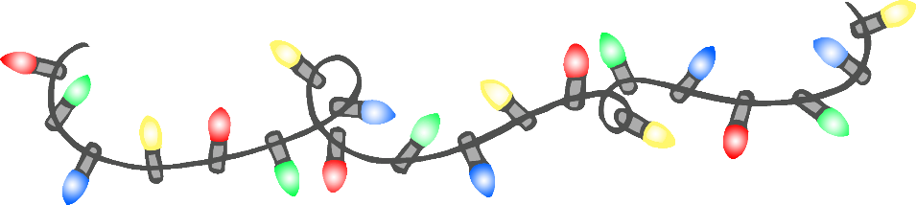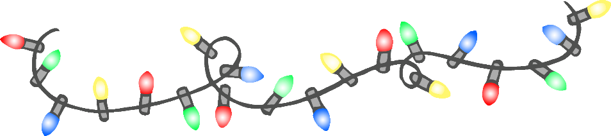

**Well Done!**

George

You ate all your lunch all week!

23/05/2020

Anna

You shared the Lego every day!

**Well Done!**

© 2020 Little Owls Resources

23/05/2020

**Well Done!**

© 2020 Little Owls Resources

William

You have been so kind!

23/05/2020

Regan

You have tidied up well all week!

**Well Done!**

© 2020 Little Owls Resources

23/05/2020

**Well Done!**

© 2020 Little Owls Resources

Freya

You used your quiet voice indoors!

23/05/2020

Jessica

You have helped your friends!

23/05/2020

**Well Done!**

© 2020 Little Owls Resources

Harry

You used your words when you were angry!

23/05/2020

**Well Done!**

© 2020 Little Owls Resources