Weather - Clothes Cut & Stick

This cut and stick activity has two suitcase outlines… one for hot, sunny weather and one for cold, rainy weather.

The children are to choose which clothes they would like (and would be appropriate for each weather type) and then cut them out to stick in the correct suitcase.

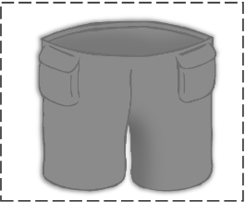

©2022 Little Owls Resources

What clothes will you take somewhere **hot** and **sunny**?

©2022 Little Owls Resources

What clothes will you take somewhere **cold** and **rainy**?

©2022 Little Owls Resources

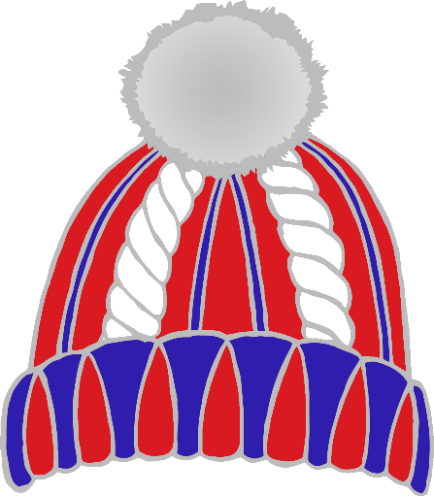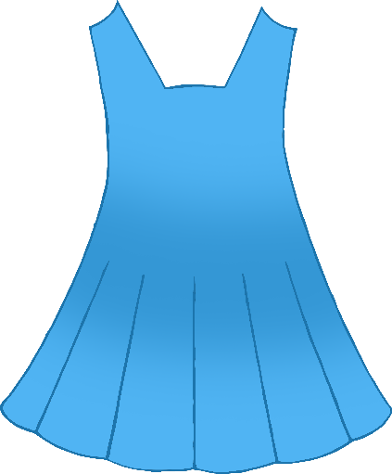

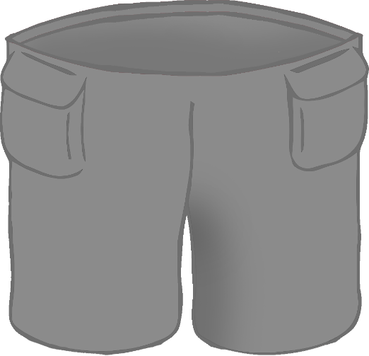

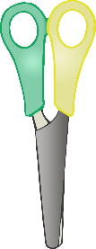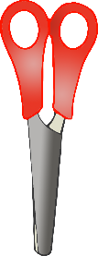

©2022 Little Owls Resources

Cut along the dashed lines.



©2022 Little Owls Resources

Cut along the dashed lines.



©2022 Little Owls Resources

Cut along the dashed lines.

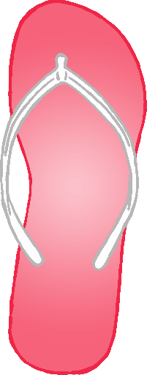



©2022 Little Owls Resources

Cut along the dashed lines.