These puzzles are intended to be printed, laminated, and cut for repeated use.

Each puzzle match shows a progression in trying hard to get better at something.

*The edges are all different so that the children can self-correct.*

‘We keep trying!’ – puzzle match

**Growth Mindset**

Keep trying!



You did it!

© 2022 Little Owls Resources



Keep trying!



You did it!

© 2022 Little Owls Resources



Keep trying!



You did it!

© 2022 Little Owls Resources



Keep trying!



You did it!

© 2022 Little Owls Resources



Keep trying!



You did it!

© 2022 Little Owls Resources



Keep trying!



You did it!

© 2022 Little Owls Resources



Keep trying!



You did it!

© 2022 Little Owls Resources



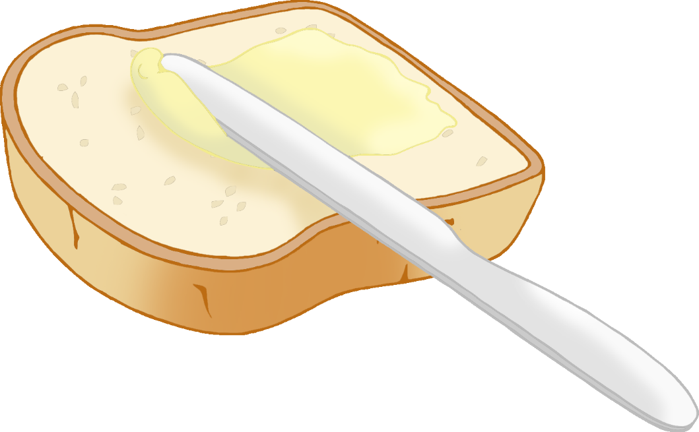

Keep trying!



You did it!

© 2022 Little Owls Resources



Keep trying!



You did it!

© 2022 Little Owls Resources



Keep trying!



You did it!

© 2022 Little Owls Resources



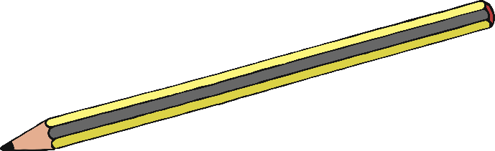

Keep trying!



You did it!

© 2022 Little Owls Resources



1 + 1 = 2

1 + 1 =

Keep trying!



You did it!

© 2022 Little Owls Resources



It’s okay, I know you didn’t mean it.

GRRRR!

I’m sorry!

I’m sorry!

Keep trying!



You did it!

© 2022 Little Owls Resources

