© 2021 Little Owls Resources

**bubble**

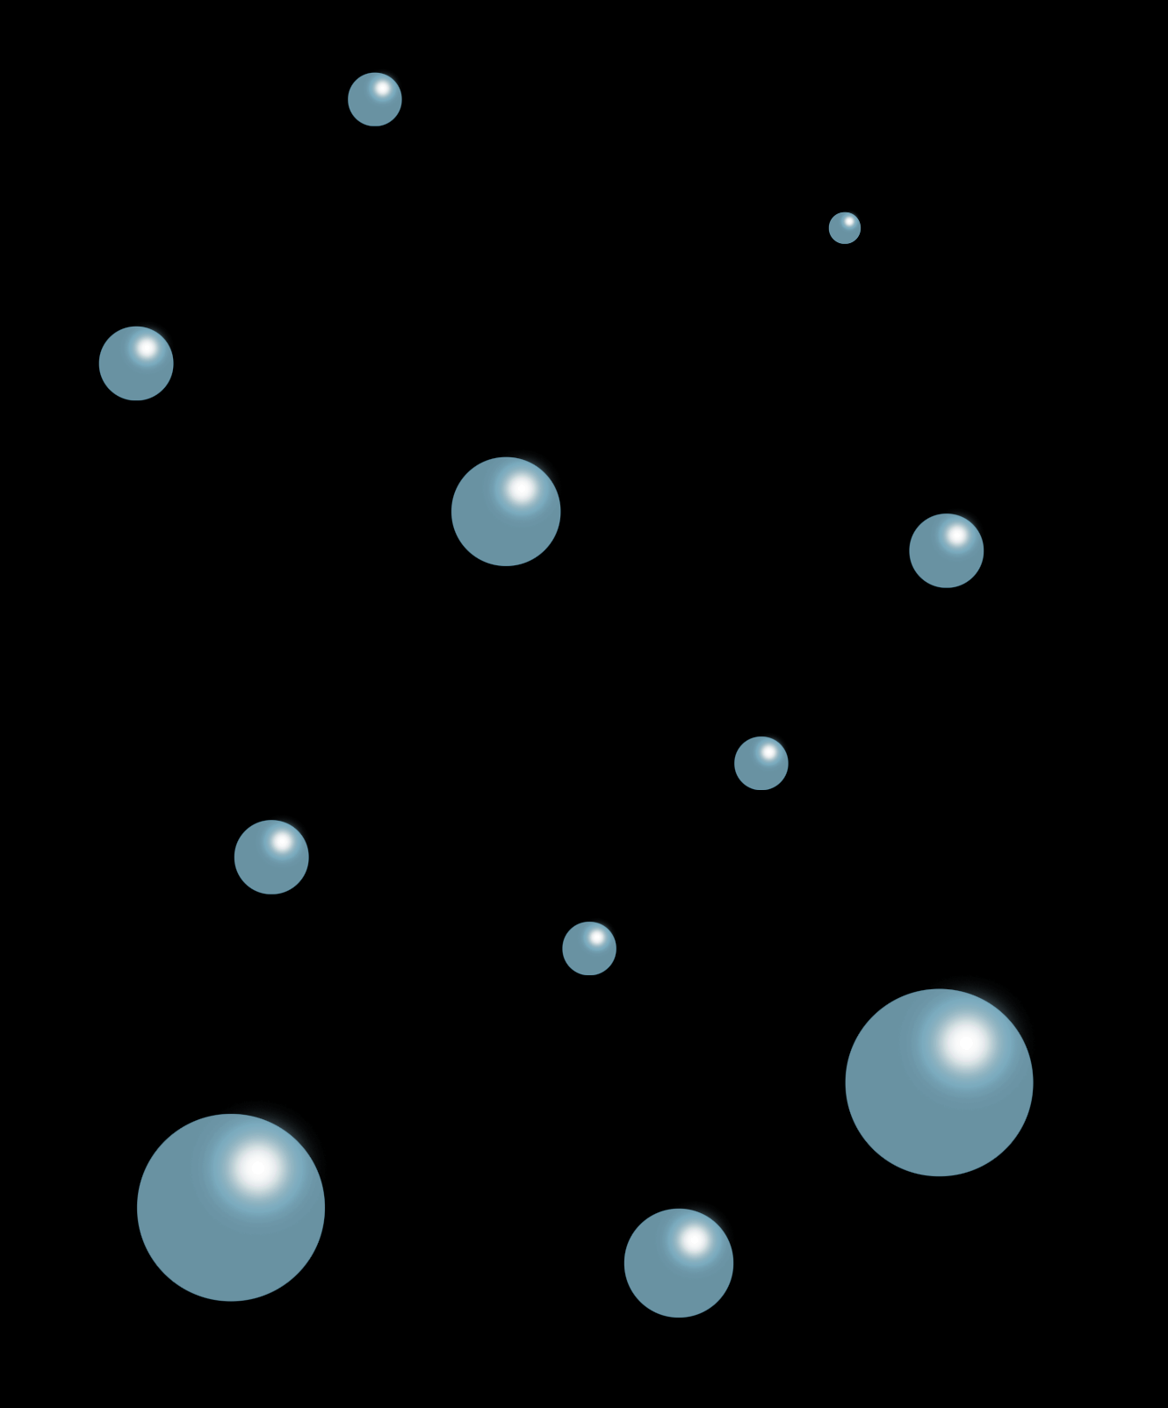

© 2021 Little Owls Resources

**drip**

© 2021 Little Owls Resources

**splash**

© 2021 Little Owls Resources

**splish**

© 2021 Little Owls Resources

**splosh**