**Plant Monitor**

© 2020 Little Owls Resources



**Plant Monitor**

© 2020 Little Owls Resources



**Plant Monitor**

© 2020 Little Owls Resources



**Plant Monitor**

© 2020 Little Owls Resources



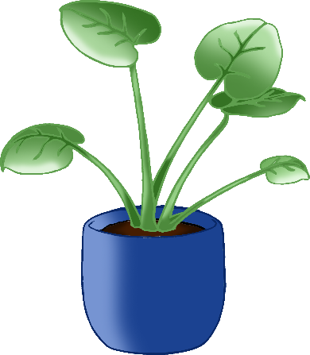

**Don’t forget**

**to water the plants!**

© 2020 Little Owls Resources

**Write your name here when you water the plants.**

© 2020 Little Owls Resources

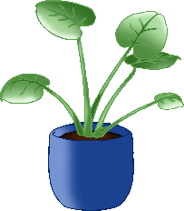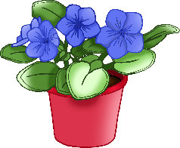

_______________________________________________________________________________________________________________________

**Write your name here when you water the plants.**

© 2020 Little Owls Resources

