Incy Wincy Spider climbed up the waterspout.

Down came the rain and washed the spider out.

Out came the sun and dried up all the rain.

So, Incy Wincy Spider climbed up the spout again.



**Incy Wincy Spider**

Sing once through as you wash your hands!

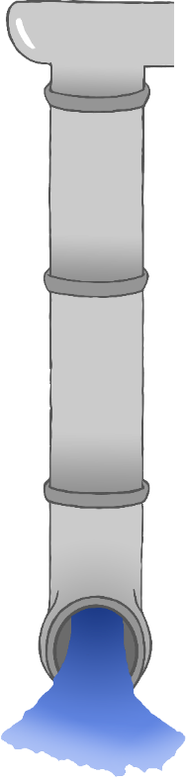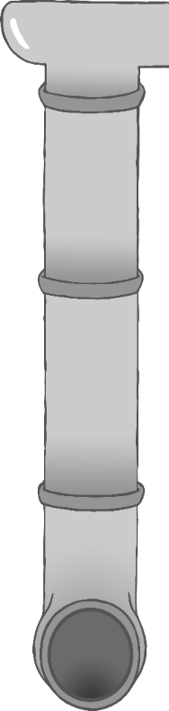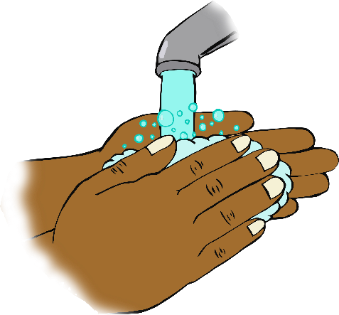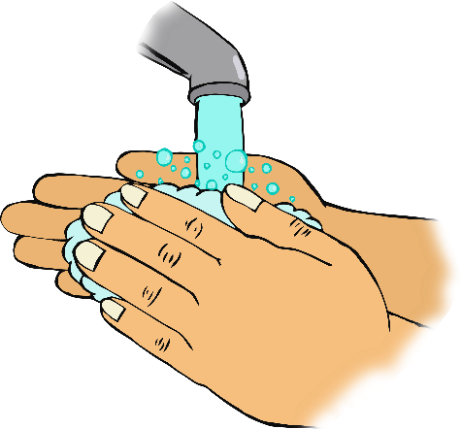

Itsy Bitsy Spider climbed up the waterspout.

Down came the rain and washed the spider out.

Out came the sun and dried up all the rain.

So, Itsy Bitsy Spider climbed up the spout again.

**Itsy Bitsy Spider**

Sing once through as you wash your hands!