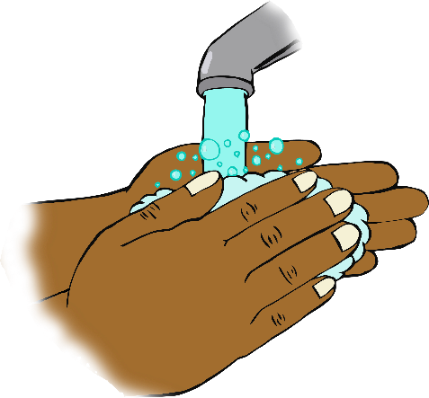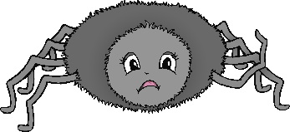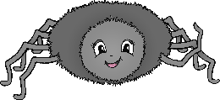

© 2020 Little Owls Resources

**Incy Wincy Spider climbed up the waterspout.**

**Down came the rain and washed the spider out.**

**Out came the sun and dried up all the rain.**

**So, Incy Wincy Spider climbed up the spout again.**

**Incy Wincy Spider**

Sing once through as you wash your hands!

© 2020 Little Owls Resources

**Itsy Bitsy Spider climbed up the waterspout.**

**Down came the rain and washed the spider out.**

**Out came the sun and dried up all the rain.**

**So, Itsy Bitsy Spider climbed up the spout again.**

**Itsy Bitsy Spider**

Sing once through as you wash your hands!