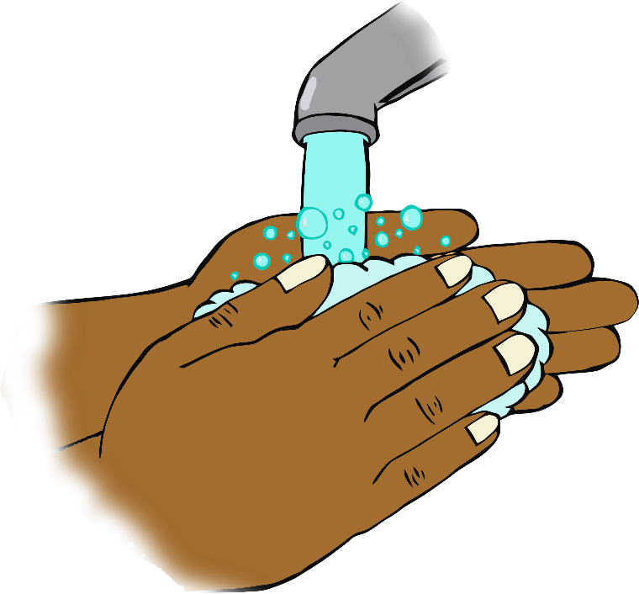

© 2020 Little Owls Resources

**Hickory Dickory Dock,**

**The mouse ran up the clock.**

**The clock struck one,**

**The mouse ran down!**

**Hickory Dickory Dock.**

**Sing twice through as you wash your hands!**

**Hickory Dickory Dock**