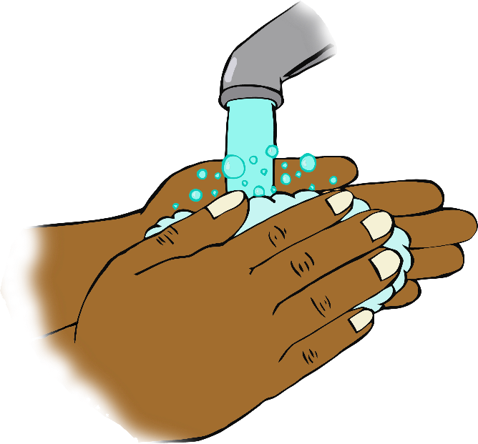

© 2020 Little Owls Resources

Sing twice through as you wash your hands!

**Hey diddle diddle,**

**the cat and the fiddle,**

**the cow jumped over the moon.**

**The little dog laughed,**

**to see such fun,**

**and the dish ran away with the spoon.**

**Hey Diddle Diddle**