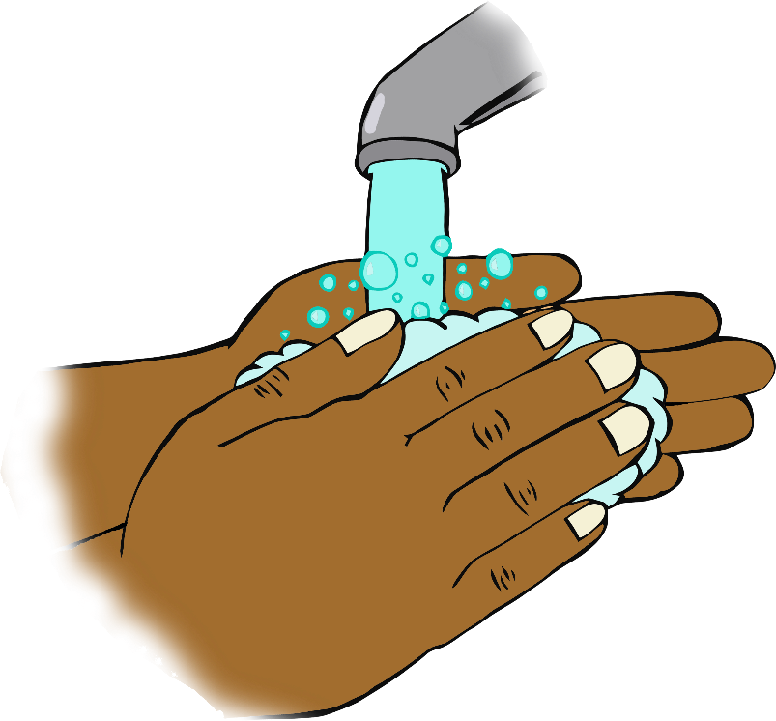

**If you’re happy and you know it wash your hands!**

Sing twice through as you wash your hands!

If you're happy and you know it, wash your hands!

If you're happy and you know it, wash your hands!

If you're happy and you know it,

and you really want to show it,

If you're happy and you know it, wash your hands!