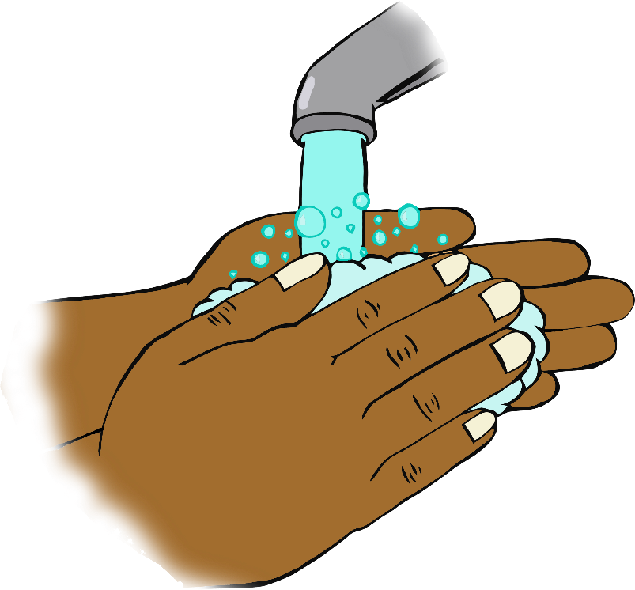

© 2020 Little Owls Resources

**If you’re happy and you know it wash your hands!**

**Sing twice through as you wash your hands!**

**If you're happy and you know it, wash your hands!**

**If you're happy and you know it, wash your hands!**

**If you're happy and you know it,**

**and you really want to show it,**

**If you're happy and you know it, wash your hands!**