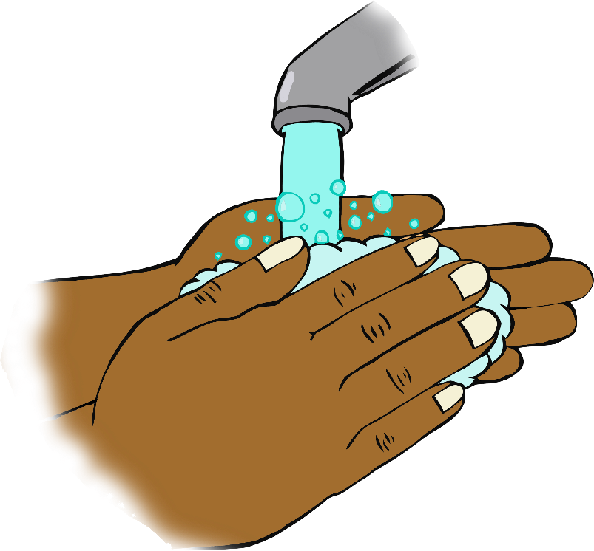

Happy Birthday to you!

Happy Birthday to you!

Happy Birthday dear ……….

Happy Birthday to you!

**Happy Birthday!**

Sing twice through as you wash your hands!