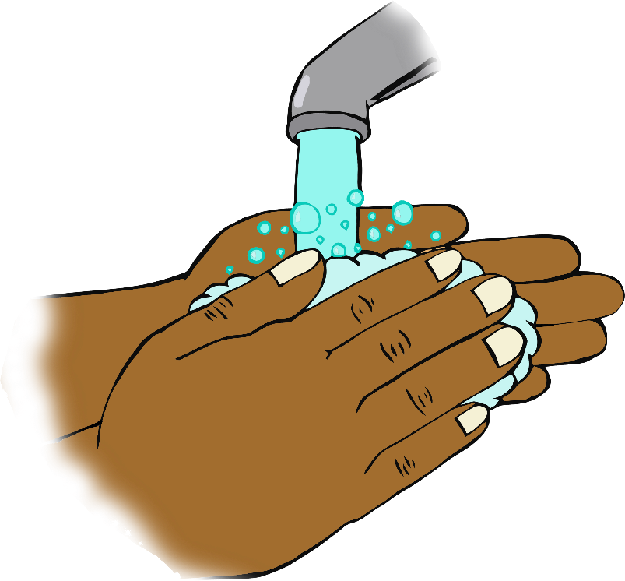

© 2020 Little Owls Resources

**Happy Birthday to you!**

**Happy Birthday to you!**

**Happy Birthday dear ……….**

**Happy Birthday to you!**

**Happy Birthday!**

**Sing twice through as you wash your hands!**