**your**

**Wash**

© 2020 Little Owls Resources

**hands!**

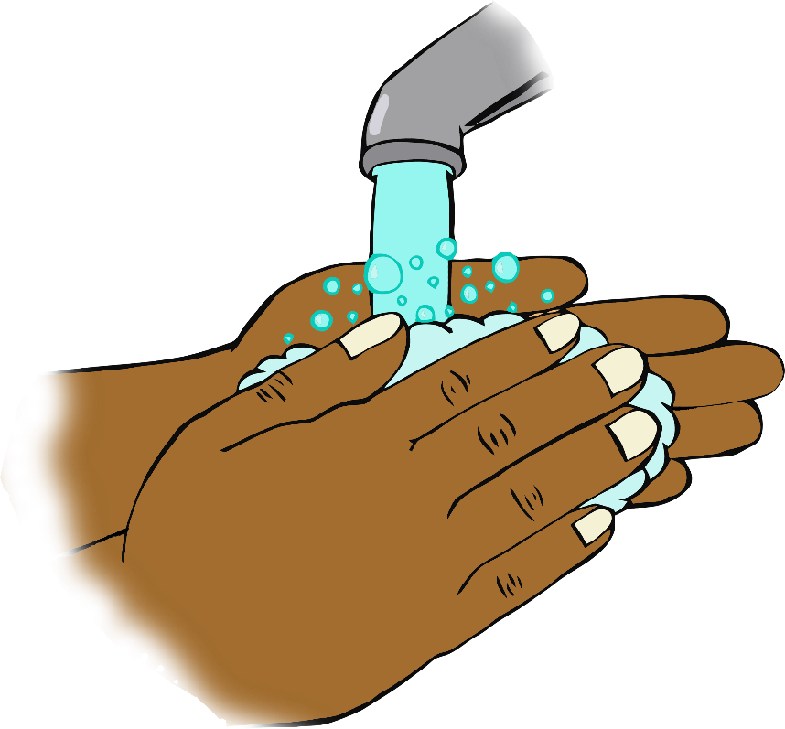

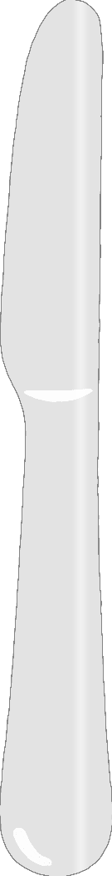

**After handling animals…**

**Before eating…**

**After playtime…**

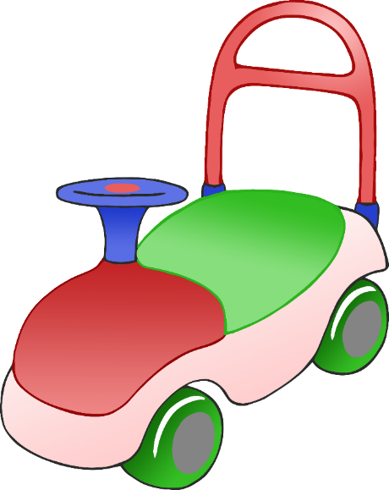

“Hello!”

**When you arrive…**

**Before cooking…**

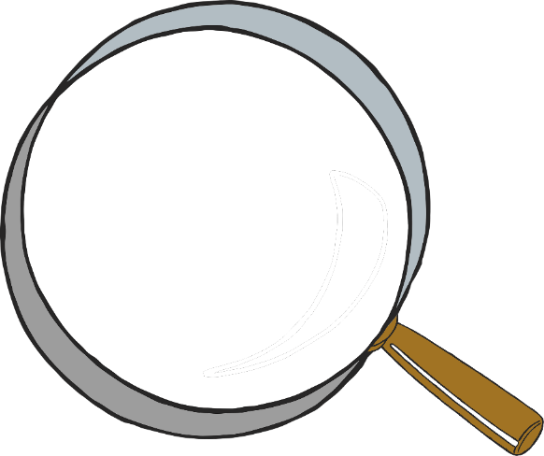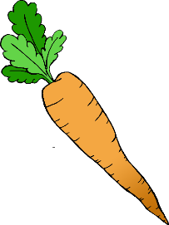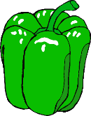

**After being in the outdoor area…**

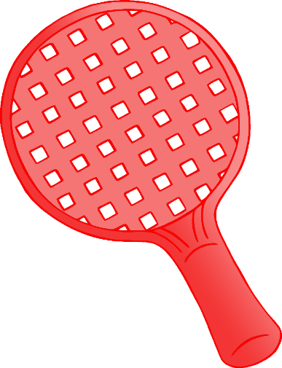

**After playing sport…**

**After using the toilet…**

**After you cough, sneeze or blow your nose…**

