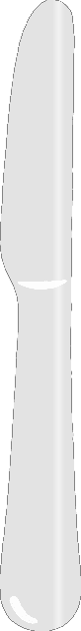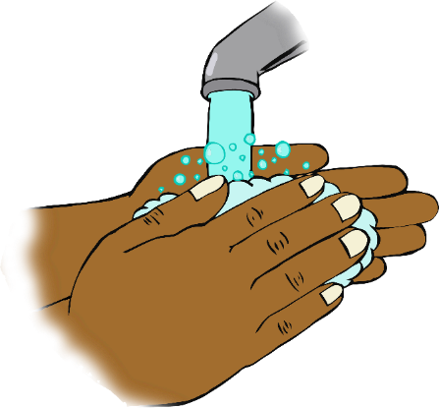

**Wash your hands!**

**Don’t forget!**