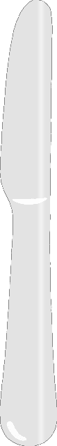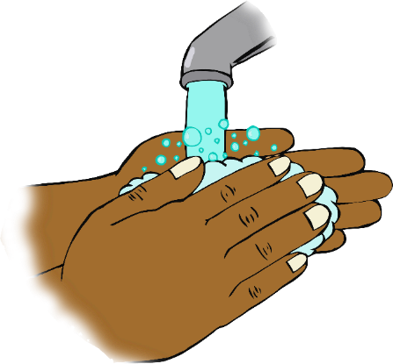

© 2020 Little Owls Resources

**Wash your hands!**

**Don’t forget!**