*

c

)

**Arts and**

**Crafts Wall**

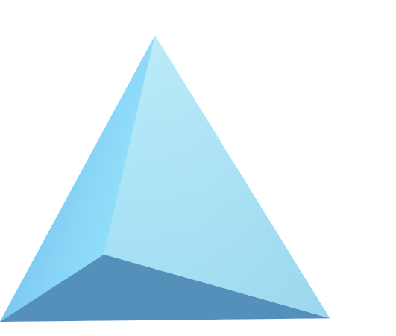

© 2020 Little Owls Resources

© 2020 Little Owls Resources

2

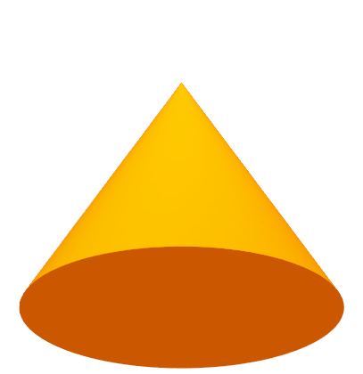

4

3

**Maths**

7

3



8

© 2020 Little Owls Resources

**Wall**

Writing

s

k

d

a

© 2020 Little Owls Resources

Wall

Investigation

Wall

© 2020 Little Owls Resources

Music

Wall

© 2020 Little Owls Resources

**Letters**

**and**

**Wall**

**Sounds**

© 2020 Little Owls Resources

**Creative**

c

m

*

*

)

Wall

© 2020 Little Owls Resources