**Visual Timetable Cards** (A7 size)

Individual/Home

These cards can be used to build an individual timetable for a non-verbal child or one that may benefit from extra structure, advanced warning, or reassurance.

Encouraging the child to be a part of the timetable creation can be beneficial.

The cards are designed to be cut & laminated and then used as individual prompts or displayed in time order using Velcro or Blue Tac.

We have created a wide variety of cards but have also included eight blank templates at the end of the pack for you to create your own.

We hope these cards are helpful!

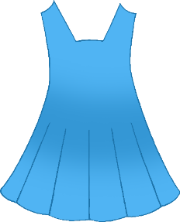

Get dressed

© 2021 Little Owls Resources

Brush teeth

© 2021 Little Owls Resources

Brush teeth

© 2021 Little Owls Resources

Eat breakfast

© 2021 Little Owls Resources

Have a drink

© 2021 Little Owls Resources

Put on boots

© 2021 Little Owls Resources

Wash hands

© 2021 Little Owls Resources

Put on coat

© 2021 Little Owls Resources

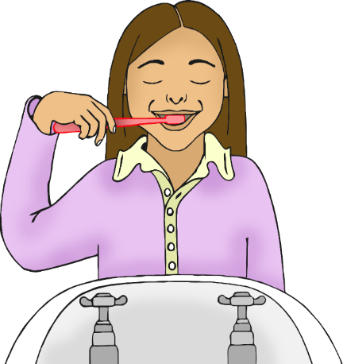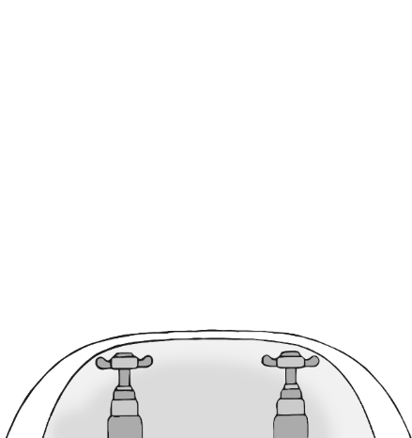

Put on jacket

© 2021 Little Owls Resources

Put on scarf

© 2021 Little Owls Resources

Put on gloves

© 2021 Little Owls Resources

Put on hat

© 2021 Little Owls Resources

Put on sun hat

© 2021 Little Owls Resources

Put on sun cream

© 2021 Little Owls Resources

Put on sunglasses

© 2021 Little Owls Resources

Go to the toilet

© 2021 Little Owls Resources

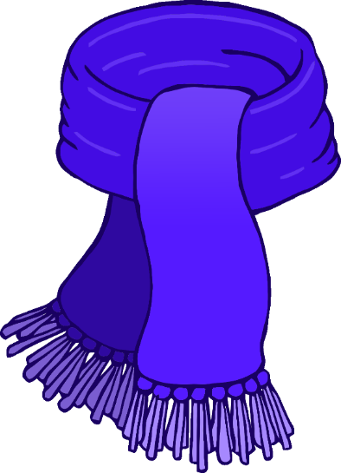

Put on shoes

© 2021 Little Owls Resources

Play outdoors

© 2021 Little Owls Resources

Play indoors

© 2021 Little Owls Resources

Eat lunch

© 2021 Little Owls Resources

Eat dinner

© 2021 Little Owls Resources

Go to school

© 2021 Little Owls Resources

Go to nursery

© 2021 Little Owls Resources

Go to preschool

© 2021 Little Owls Resources

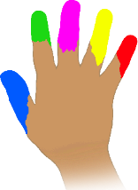

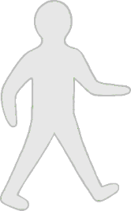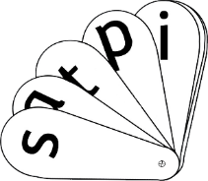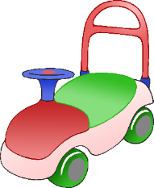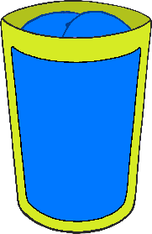

cat

Go to childminder

© 2021 Little Owls Resources

Bath time

© 2021 Little Owls Resources

Bedtime story

© 2021 Little Owls Resources

Go to sleep

© 2021 Little Owls Resources

Put on Pyjamas

© 2021 Little Owls Resources

Nap time

© 2021 Little Owls Resources

Brush hair

© 2021 Little Owls Resources

Go for a walk

© 2021 Little Owls Resources

Z

Z

Z

Z

Z

Z

Z

Z



Car trip

© 2021 Little Owls Resources

Bus trip

© 2021 Little Owls Resources

Bike ride

© 2021 Little Owls Resources

Scooter ride

© 2021 Little Owls Resources

Tablet time

© 2021 Little Owls Resources

TV time

© 2021 Little Owls Resources

Water play

© 2021 Little Owls Resources

Sand play

© 2021 Little Owls Resources

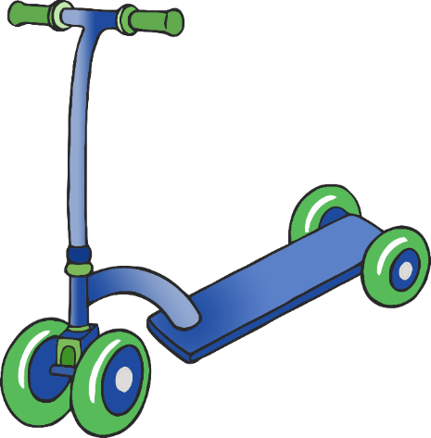

Playdough

© 2021 Little Owls Resources

Arts & Craft

© 2021 Little Owls Resources

Reading

© 2021 Little Owls Resources

Music

© 2021 Little Owls Resources

Messy Play

© 2021 Little Owls Resources

Construction

© 2021 Little Owls Resources

Small world

© 2021 Little Owls Resources

Puzzles

© 2021 Little Owls Resources

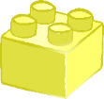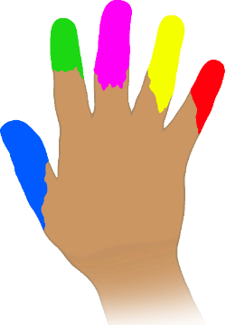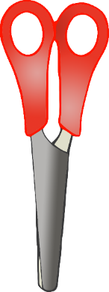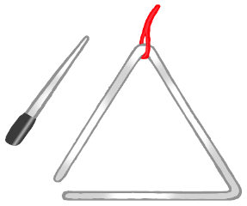

Painting

© 2021 Little Owls Resources

Singing

© 2021 Little Owls Resources

Exploring

© 2021 Little Owls Resources

Pet time

© 2021 Little Owls Resources

Dressing up

© 2021 Little Owls Resources

Physical games

© 2021 Little Owls Resources

Sensory

© 2021 Little Owls Resources

Role-Play

© 2021 Little Owls Resources

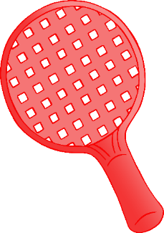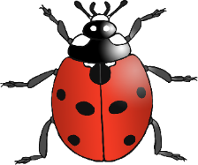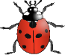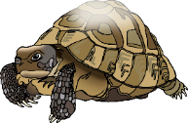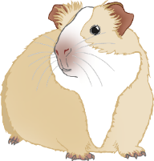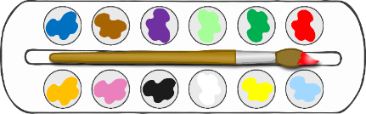

© 2021 Little Owls Resources

© 2021 Little Owls Resources

© 2021 Little Owls Resources

© 2021 Little Owls Resources

© 2021 Little Owls Resources

© 2021 Little Owls Resources

© 2021 Little Owls Resources

© 2021 Little Owls Resources