People Who Help Us

Vet

The pages of this pack give some general information about the role of a vet and some fun and engaging activities to foster and develop children’s interest in this role in society.

* Information Posters
* Information Posters (Colouring)
* Drawing/Writing Sheets
* Draw items Sheet
* Draw items Sheet (Colouring)
* Item Poster
* Item Poster (Colouring)
* Multimats for Art & Craft/Loose Parts/Playdough
* 5x 2-Piece individual items puzzles
* 1x 4-Piece all items puzzle

This pack includes:

© 2021 Little Owls Resources

© 2021 Little Owls Resources

Vet

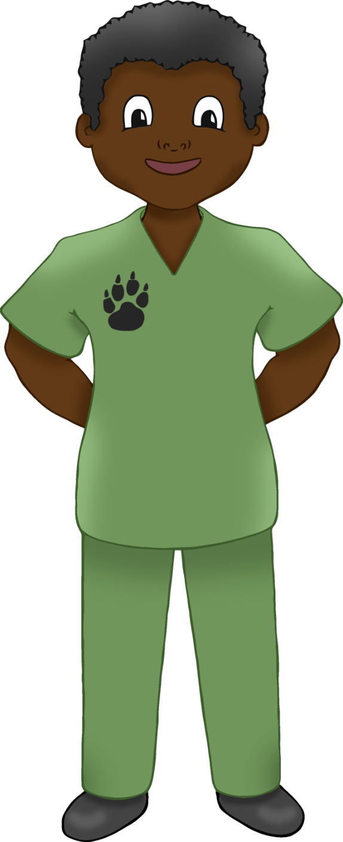

I’m a **vet.**

If an animal is sick or injured, I will do my best to help them feel better.

I know about lots of different types of animals and how to keep them happy and healthy.

I use a carry case to move animals safely.

Vet

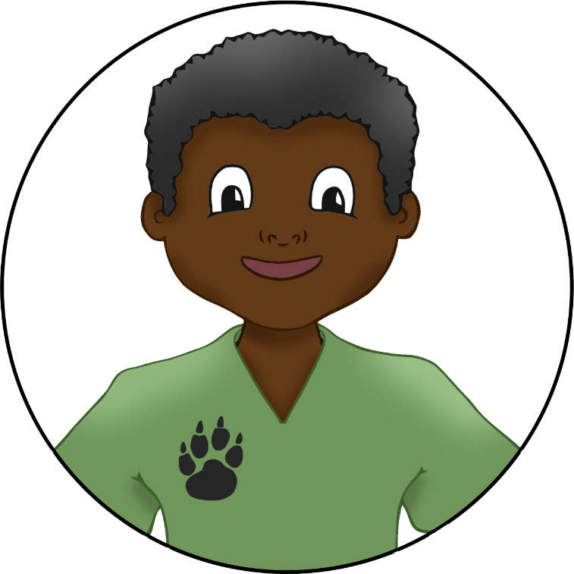

If an animal has an injury, I will dress their wounds with a bandage.

Sometimes I use a syringe to inject these medicines into the animals.

I use different medicines to help animals that are sick.

© 2021 Little Owls Resources

© 2021 Little Owls Resources

**Vet**

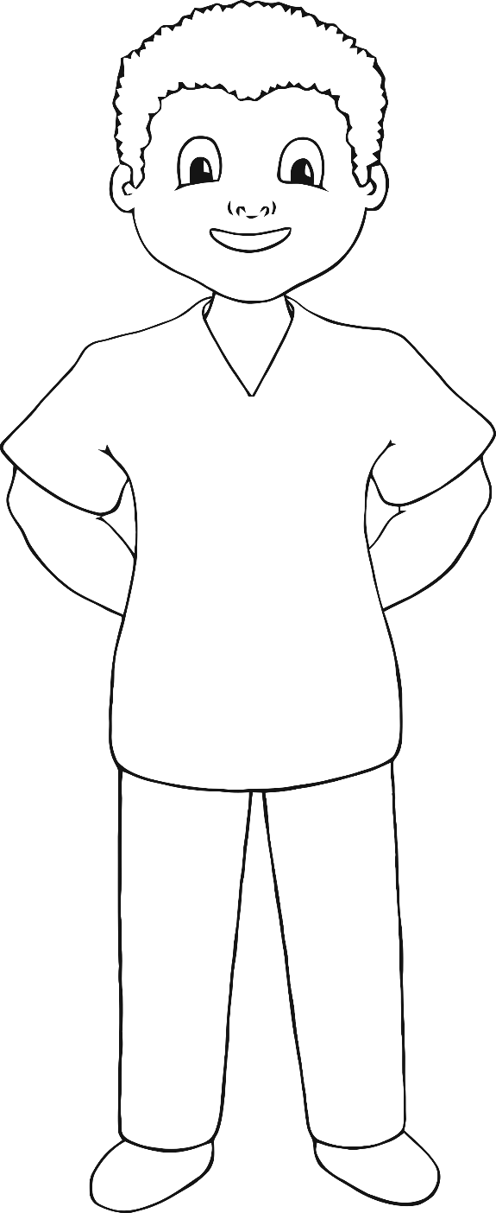

**I’m a vet.**

**If an animal is sick or injured, I will do my best to help them feel better.**

**I know about lots of different types of animals and how to keep them happy and healthy.**

**I use a carry case to move animals safely.**

**Vet**

**Sometimes I use a syringe to inject these medicines into the animals.**

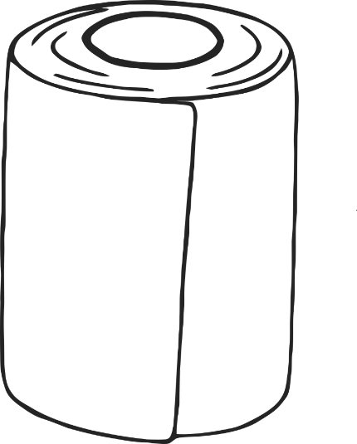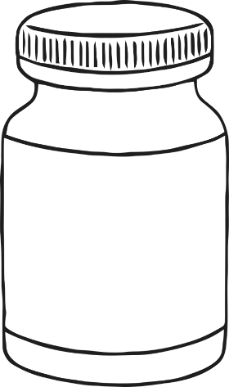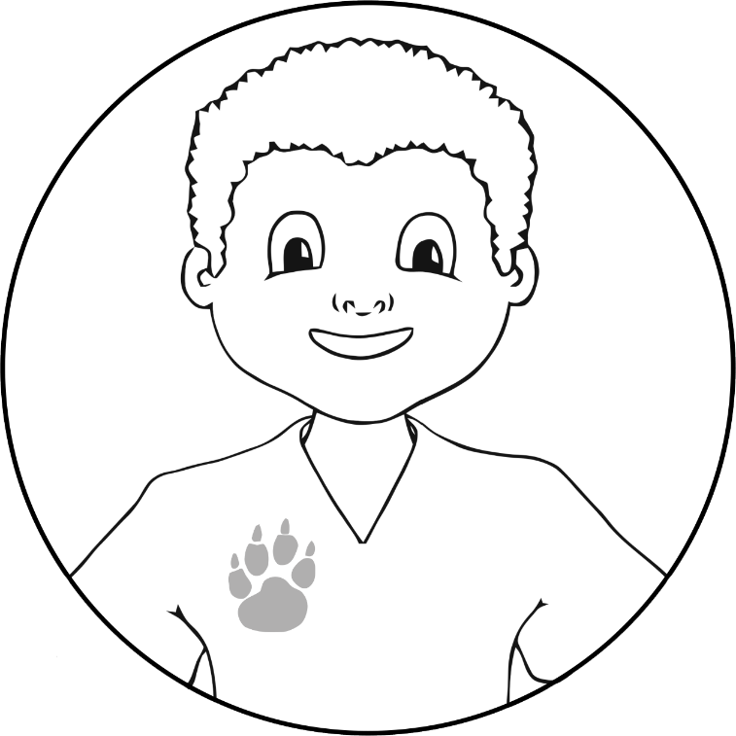

**If an animal has an injury, I will dress their wounds with a bandage.**

**I use different medicines to help animals that are sick.**

© 2021 Little Owls Resources

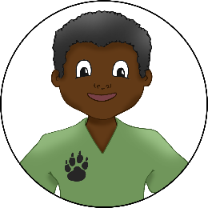

© 2021 Little Owls Resources

Draw a Vet!



© 2021 Little Owls Resources



Draw and write about a Vet!

_________________________________________________________

© 2021 Little Owls Resources

Draw and write about a Vet!

________________________________________________________________________________________________________________________________________________

**Can you draw the items a vet needs?**

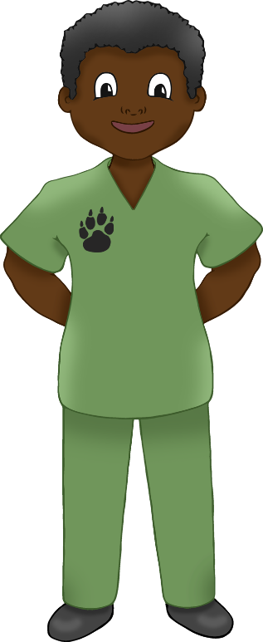

© 2021 Little Owls Resources

**Can you draw the items a vet needs?**

© 2021 Little Owls Resources

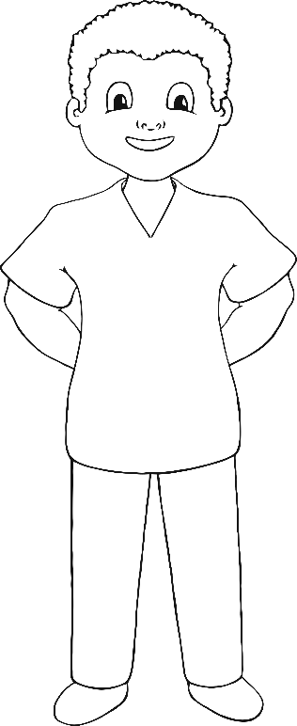

Vet

© 2021 Little Owls Resources

Syringe

Medicine

Carry Case

Bandage

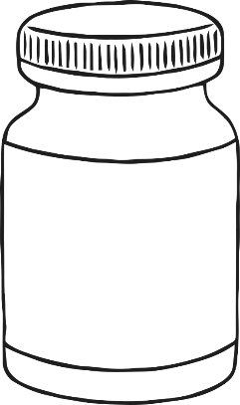

**Vet**

© 2021 Little Owls Resources

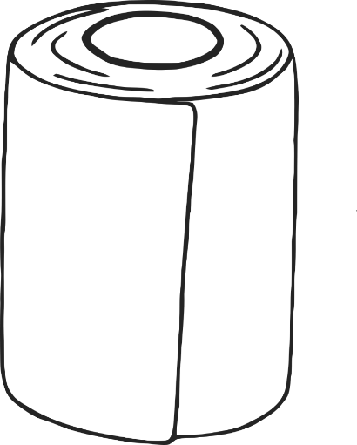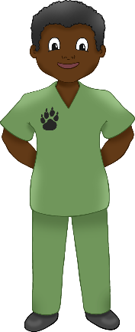

**Syringe**

**Medicine**

**Carry Case**

**Bandage**

Vet Multimat – Carry Case

© 2021 Little Owls Resources

Vet Multimat – Medicine

© 2021 Little Owls Resources

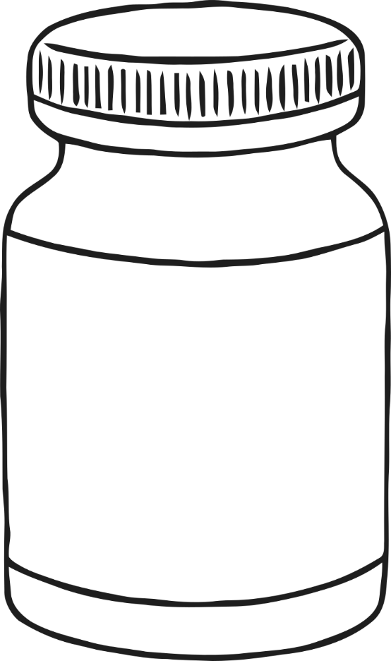

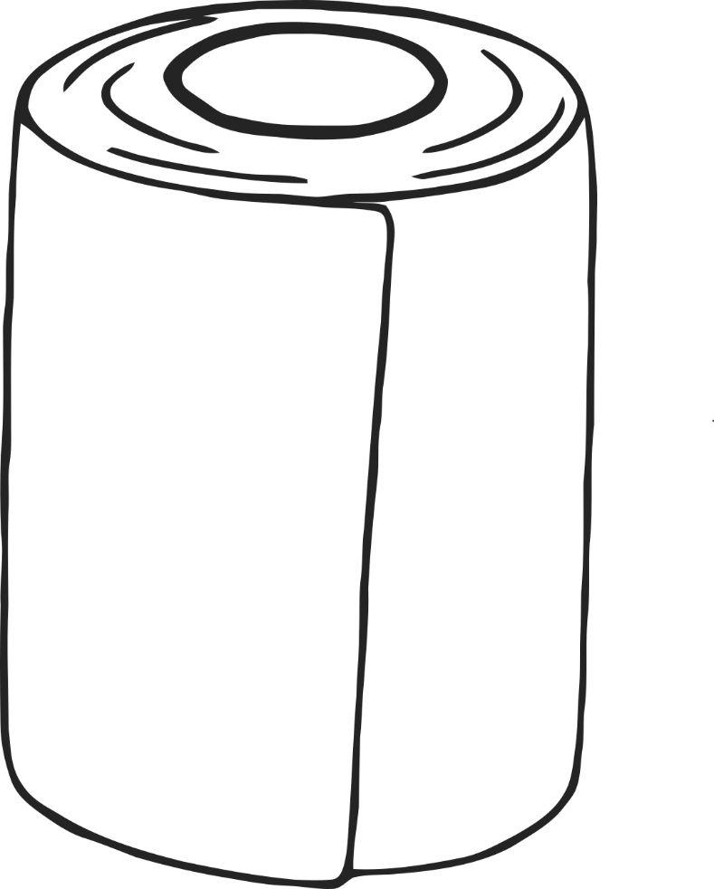

Vet Multimat – Bandage

© 2021 Little Owls Resources





Vet Multimat – Syringe

© 2021 Little Owls Resources

© 2021 Little Owls Resources

© 2021 Little Owls Resources

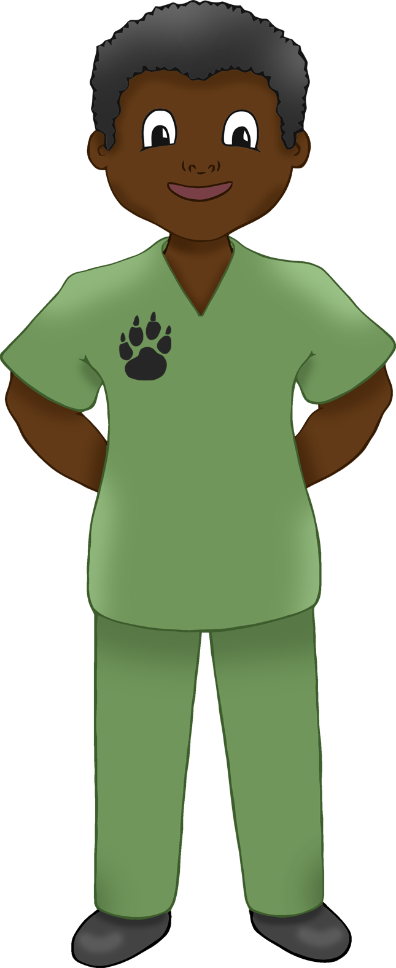

© 2021 Little Owls Resources

© 2021 Little Owls Resources

© 2021 Little Owls Resources



**Vet**

© 2021 Little Owls Resources

Carry Case

Bandage

Medicine

Syringe