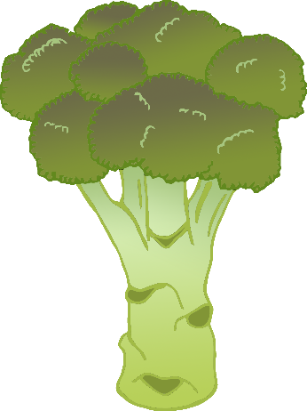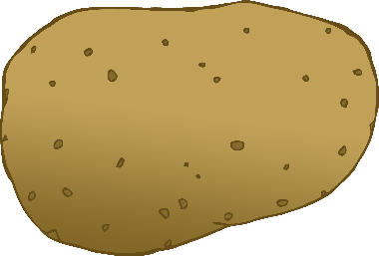\

**Vegetables**

© 2021 Little Owls Resources

cauliflower

tomato

corn

cabbage

onion

cucumber

lettuce

potato

broccoli

peas

pepper

carrot

**Vegetables**

peas

potato

cauliflower

carrot

pepper

cucumber

lettuce

broccoli

corn

cabbage

onion

© 2021 Little Owls Resources

tomato