**Vaquita**

The pages of this pack give some general information about vaquitas and some fun and engaging activities to foster and develop children’s interest in them.

**This pack includes:**

* Fact posters x3 (Could be used as stimuli for a lesson input)
* Number slice activity (1-10) (Can be pre-cut for a pure number ordering activity or left to be cut by child to add scissor practice)
* Number slice activity - colouring version (1-10) (As above but to be coloured before cutting)
* Description sheet (Can be used as an independent writing activity or with an adult scribing the ideas of a younger child)
* A4 poster
* A4 poster - colouring version
* ‘Body Parts’ x3 (fully labelled, initial sounds only, blank)
* Draw and write sheets x3 (blank sheet, wide lines and narrow lines)
* 1x 4-piece puzzle
* Multimats x3 (for Colouring/Art & Craft/Loose Parts/Playdough)

© 2021 Little Owls Resources

This pack includes:

The pages of this pack give some general information about the role of a paramedic and some fun and engaging activities to foster and develop children’s interest in this role in society.

© 2021 Little Owls Resources

**Vaquita Facts**

**10**

Vaquitas can live for

years.

**21**

Vaquita eat **small fish**.

There are only vaquitas left in the world!

Human use large nets to catch fish. Vaquitas get caught in the nets and die.

This means there is a very high risk that they may become extinct.

**Vaquitas are** Endangered.

© 2021 Little Owls Resources

**How big is a Vaquita?**



150cm / 1.5m

© 2021 Little Owls Resources

1

2

3

4

5

6

7

8

9

10

© 2021 Little Owls Resources

© 2021 Little Owls Resources

1

2

3

4

5

6

7

8

9

10

© 2021 Little Owls Resources

**What words would you use to describe a vaquita?**

**Vaquita**

© 2021 Little Owls Resources

**Vaquita**

© 2021 Little Owls Resources

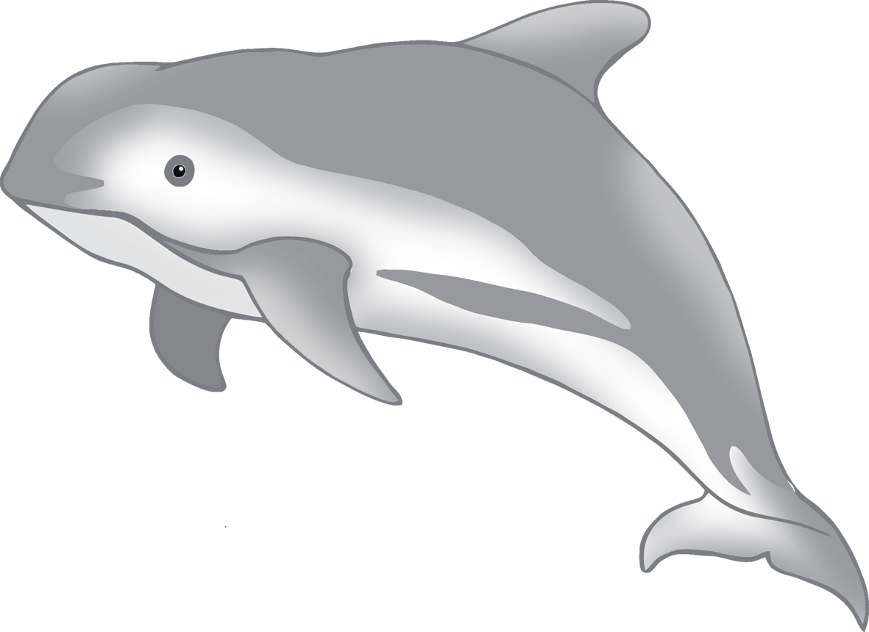

**Vaquita body parts**

© 2021 Little Owls Resources

fin

blowhole

mouth

tail

eye



**Vaquita body parts**

© 2021 Little Owls Resources

f

b

m

t

e



**Vaquita body parts**

© 2021 Little Owls Resources

© 2021 Little Owls Resources

**Draw a Vaquita!**

© 2021 Little Owls Resources

**Draw and write about a Vaquita!**

____________________________________________________

© 2021 Little Owls Resources

**Draw and write about a Vaquita!**

______________________________________________________________________________________________________

**Vaquita**

© 2021 Little Owls Resources

© 2021 Little Owls Resources

**Vaquita Multimat – Vaquita**

© 2021 Little Owls Resources

**Vaquita Multimat – Vaquitas**

© 2021 Little Owls Resources

**Vaquita Multimat – Vaquita and Fish**

