Love

©2024 Little Owls Resources

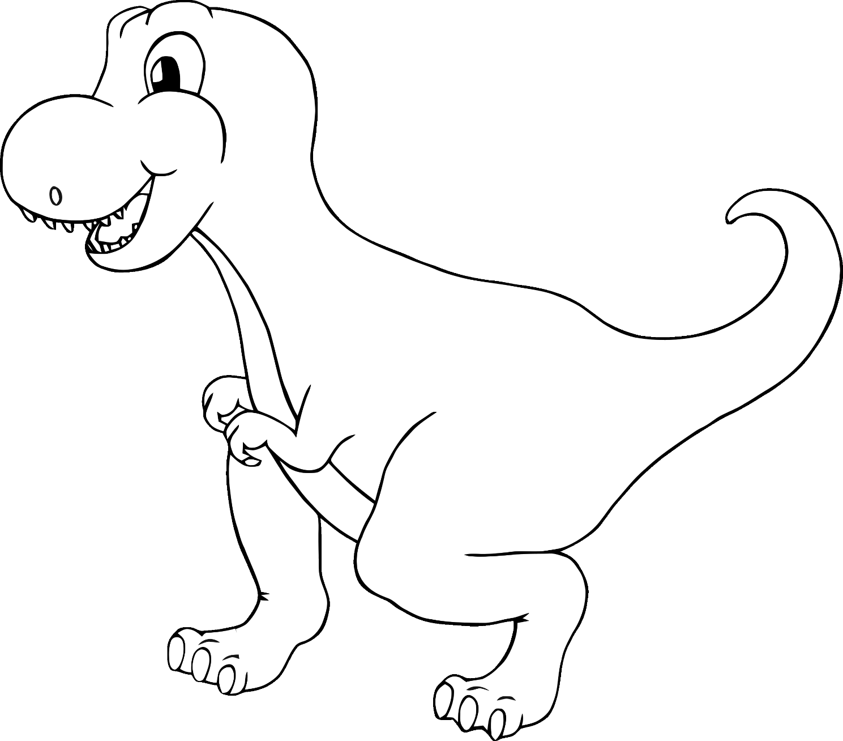

**You are so**

**!**

**roarsome**

©2024 Little Owls Resources

‘eye’ love you!

©2024 Little Owls Resources



sunshine!

You are my

©2024 Little Owls Resources

Love!

©2024 Little Owls Resources

Happy Valentine’s Day!

©2024 Little Owls Resources