Party Pack

**Valentine’s Day**

Pack includes:

*(Number in brackets shows how many A4 pages)*

* Valentine bunting (4)
* Blank bunting (1)
* Valentine posters (2)
* Valentine colouring placemats (2)
* Blank placemat (1)
* Colouring ‘Valentine’s Day’ cards (10)
* ‘Heart Eyes’ colouring masks (9)
* Heart drawing sheet outline (1)
* Colouring party tickets (1)
* Blank party tickets (1)
* Valentine posters (9)
* Valentine party invitation writing templates (3)
* Valentine party time drawing sheet (1)

© 2020 Little Owls Resources

c

© 2023 Little Owls Resources

c

© 2023 Little Owls Resources

c

© 2023 Little Owls Resources

c

© 2023 Little Owls Resources

c

© 2023 Little Owls Resources

c

© 2020 Little Owls Resources

c

© 2023 Little Owls Resources

c

© 2023 Little Owls Resources

c

© 2023 Little Owls Resources

c

© 2023 Little Owls Resources

c

**Happy Valentine’s Day!**

© 2023 Little Owls Resources

c

**LOVE!**

© 2023 Little Owls Resources

c

© 2023 Little Owls Resources

© 2023 Little Owls Resources

© 2023 Little Owls Resources

1

© 2022 Little Owls Resources

Happy

Valentine’s

Day!

© 2023 Little Owls Resources

Be my Valentine!

© 2023 Little Owls Resources

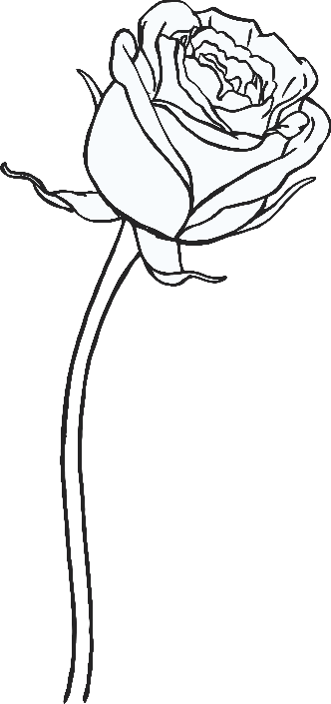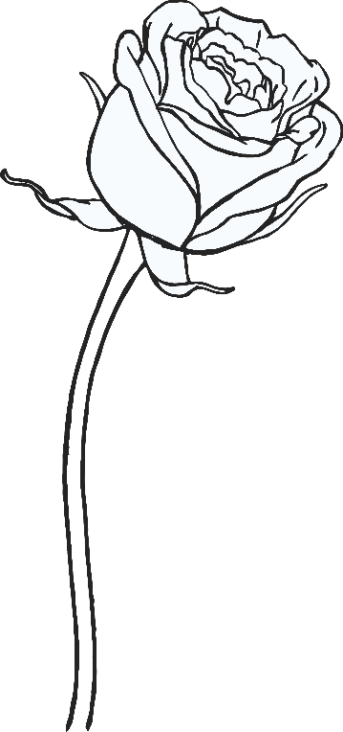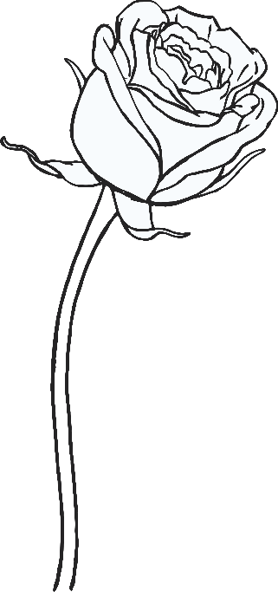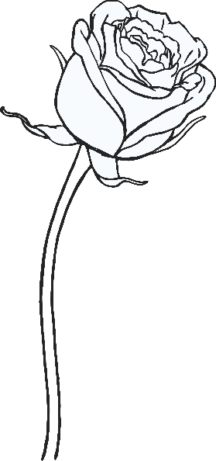

love

you!

© 2023 Little Owls Resources

I

© 2023 Little Owls Resources

LOVE

© 2023 Little Owls Resources

Happy

VALENTINE’S

DAY

© 2023 Little Owls Resources



Happy

Valentine’s Day!

© 2023 Little Owls Resources

I love you!

© 2023 Little Owls Resources

LOVE

© 2023 Little Owls Resources

Be my Valentine!

Happy

Valentine’s Day!

© 2023 Little Owls Resources

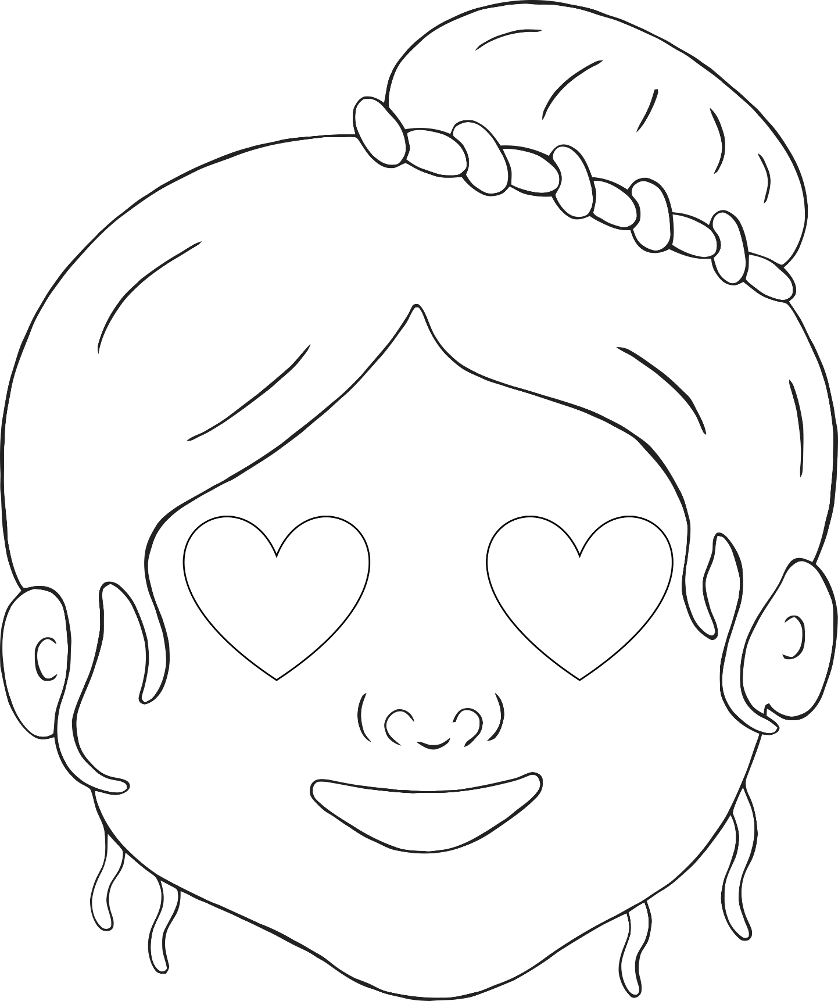

© 2023 Little Owls Resources

© 2023 Little Owls Resources

© 2023 Little Owls Resources

© 2023 Little Owls Resources

© 2023 Little Owls Resources

© 2023 Little Owls Resources

© 2023 Little Owls Resources

© 2023 Little Owls Resources

© 2023 Little Owls Resources

© 2023 Little Owls Resources

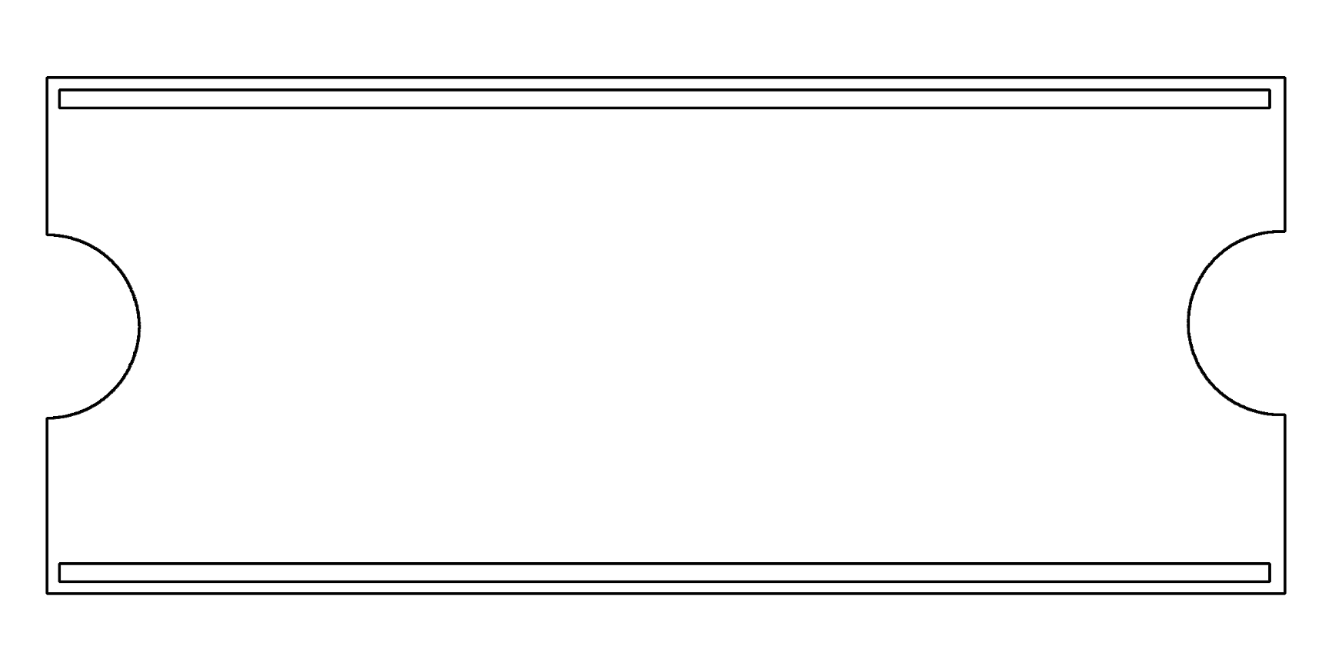

**My Party Ticket**



**My Party Ticket**



Love

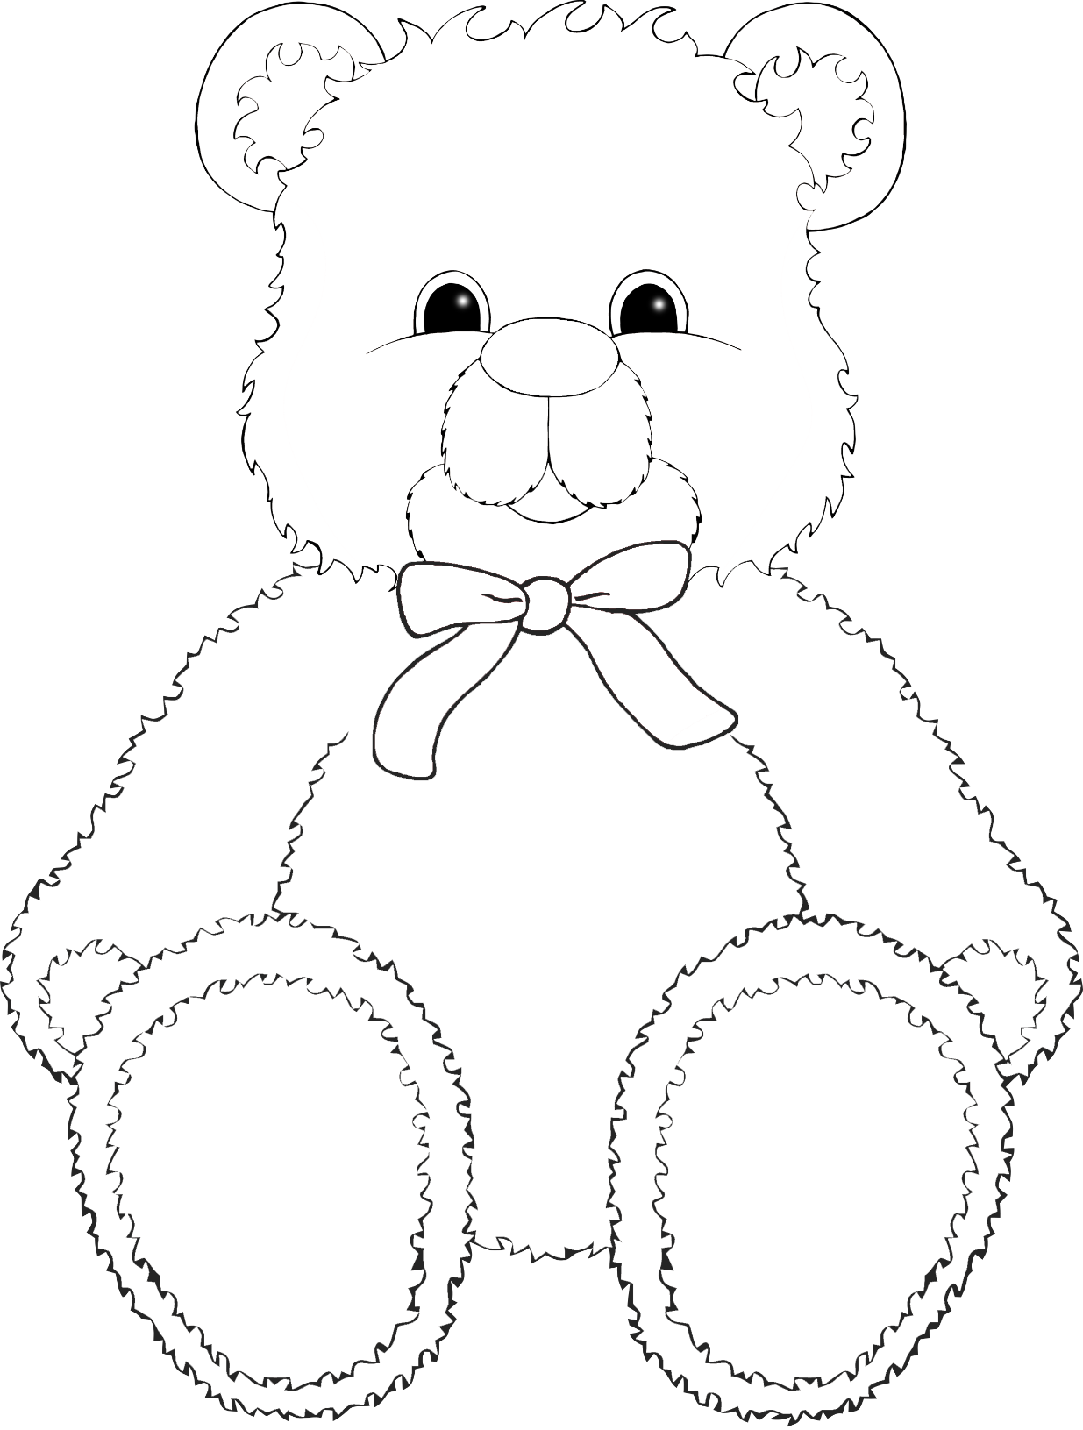

©2022 Little Owls Resources

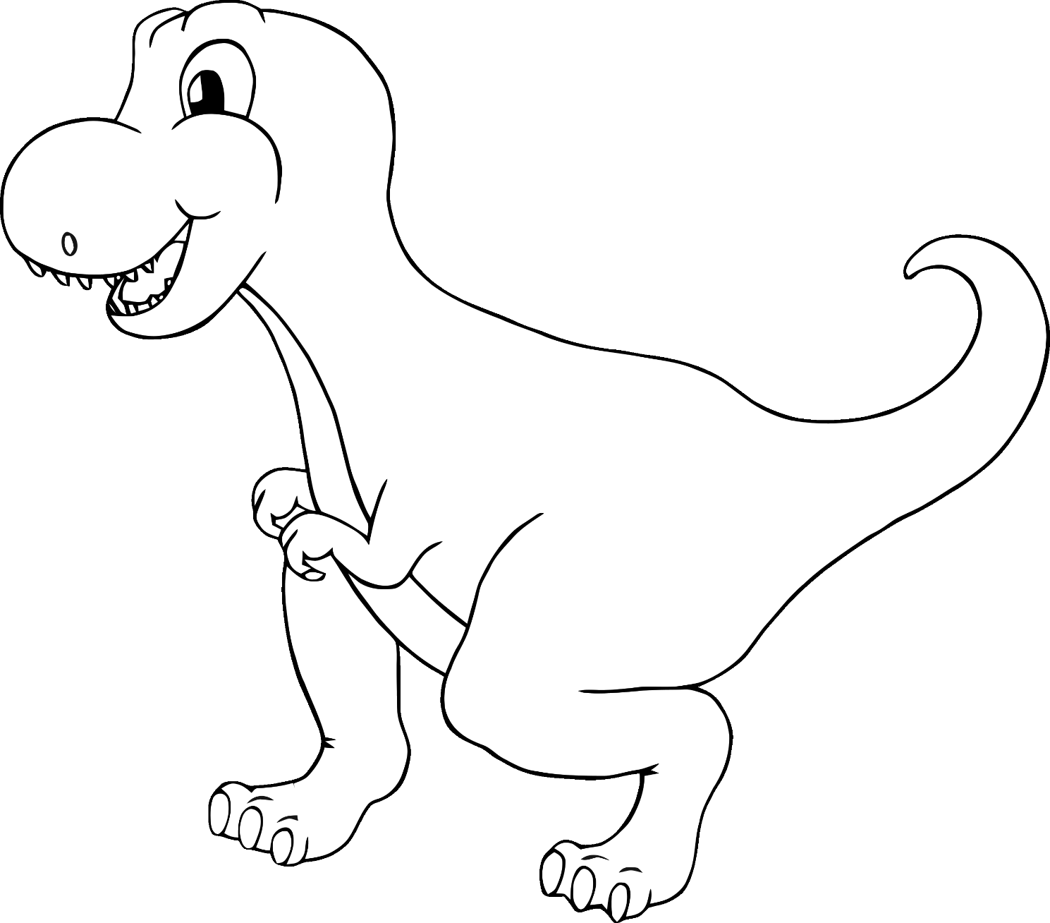

**You are so**

**!**

**roarsome**

©2022 Little Owls Resources

‘eye’ love you!

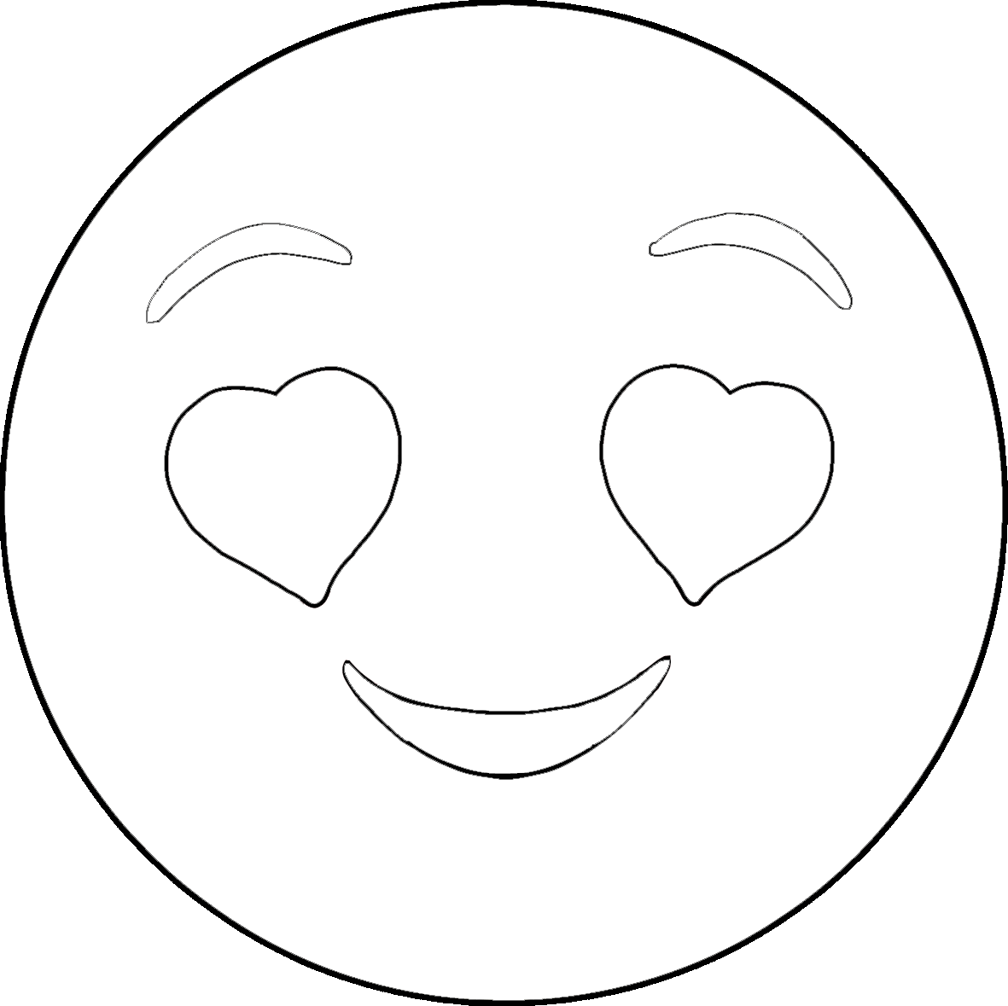

©2022 Little Owls Resources

sunshine!

You are my

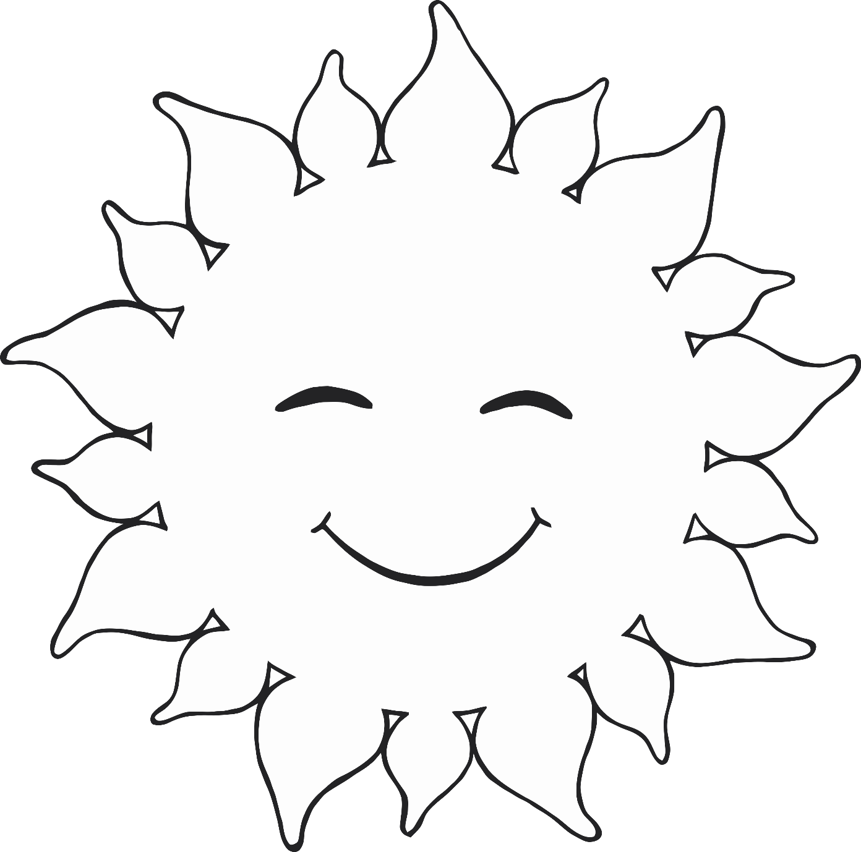

©2022 Little Owls Resources

You make

me very happy!

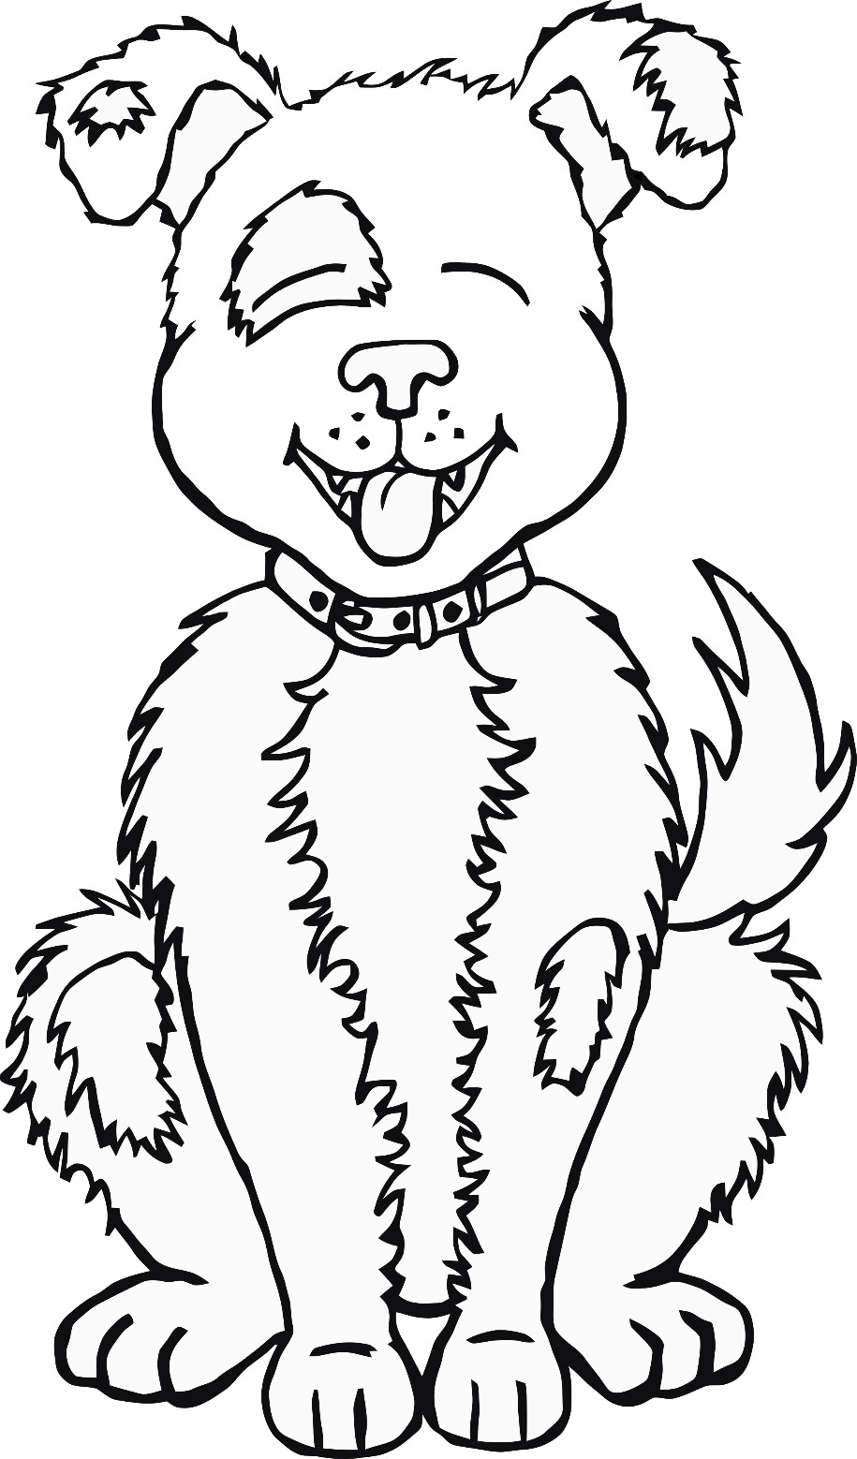

©2022 Little Owls Resources

You’re magical!

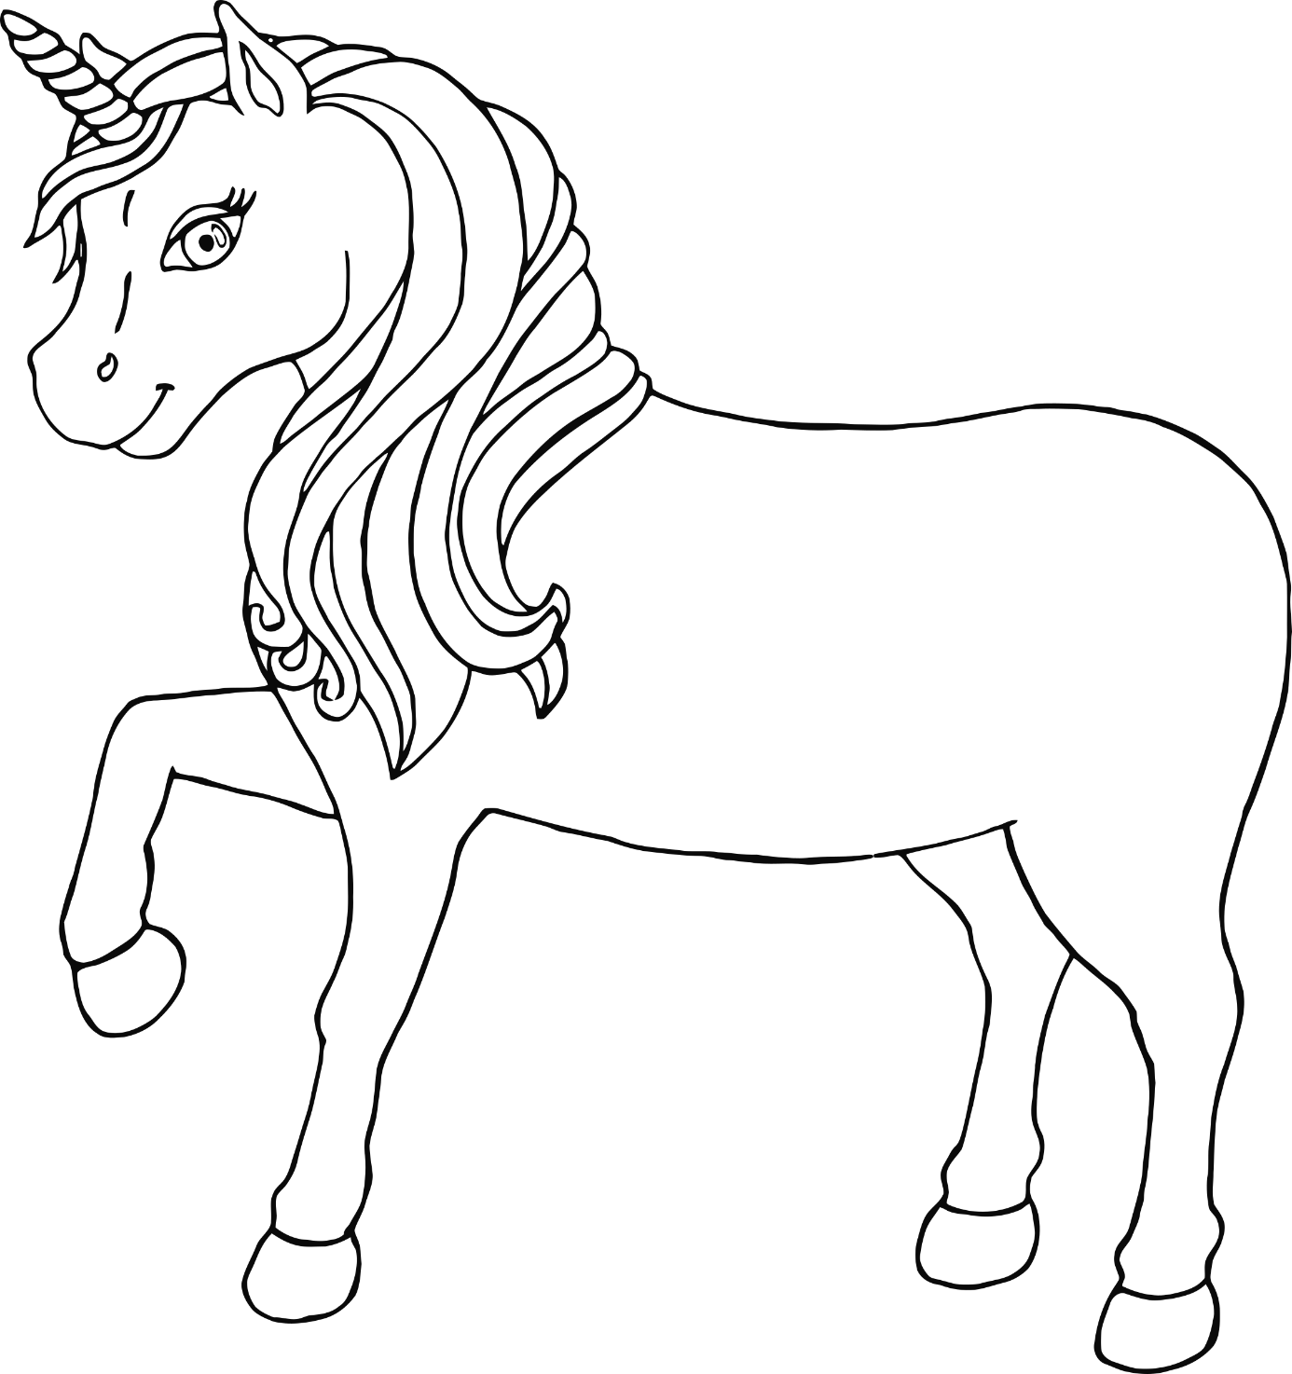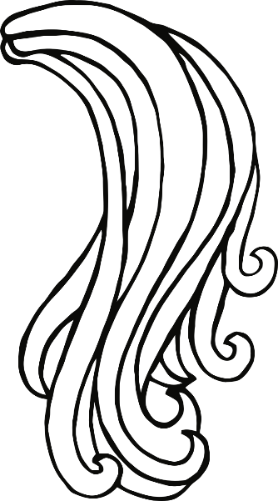

©2022 Little Owls Resources

You are a STAR!

Happy

Valentine’s Day!

©2022 Little Owls Resources

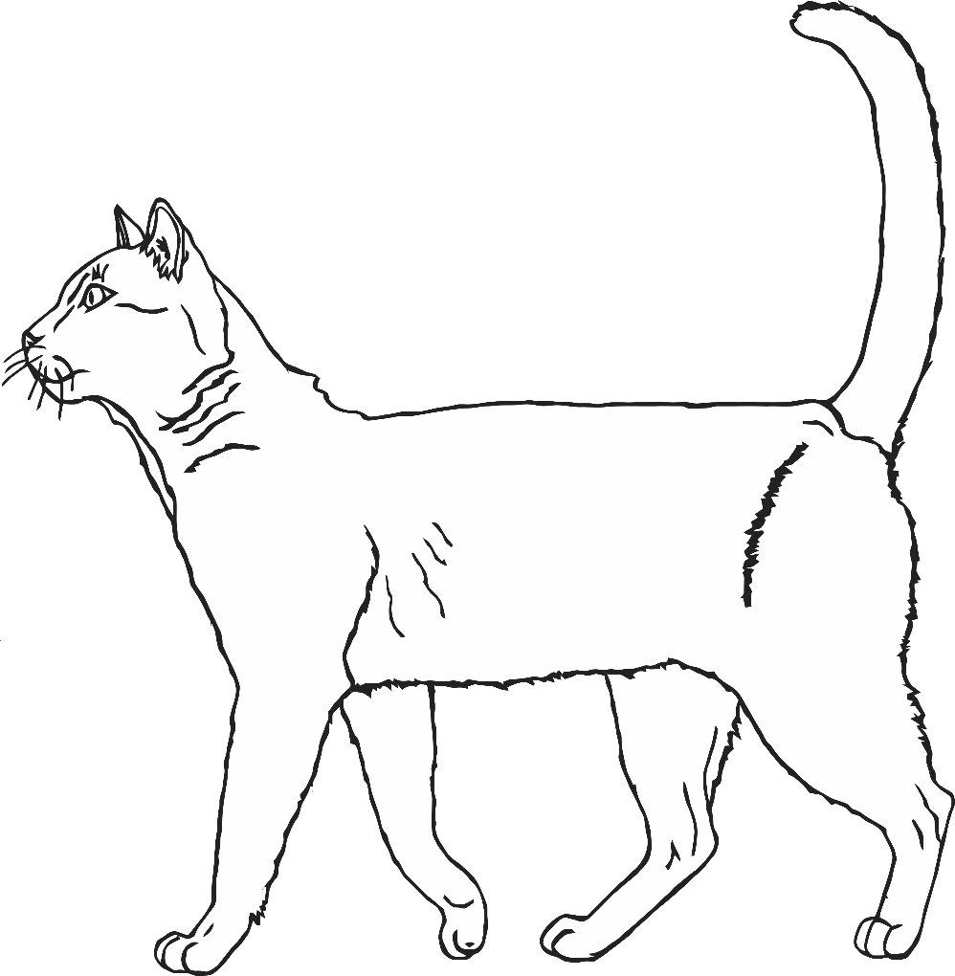

You’re purr-fect!

Happy Valentine’s Day!

©2022 Little Owls Resources

Happy Valentine’s Day!

©2022 Little Owls Resources

**Party Invitation**

© 2023 Little Owls Resources

Dear_____________

You are invited to a Valentine’s Day Party!

Love from

__________________

**Party Invitation**

© 2023 Little Owls Resources

Dear_____________

________________________________________________________________________

Love from __________________

**Party Invitation**

© 2023 Little Owls Resources

______________________________________________________________________________________________________________________________

**Party Invitation**

© 2023 Little Owls Resources