Happy

Valentine’s

Day!

© 2019 Little Owls Resources

Be my Valentine!

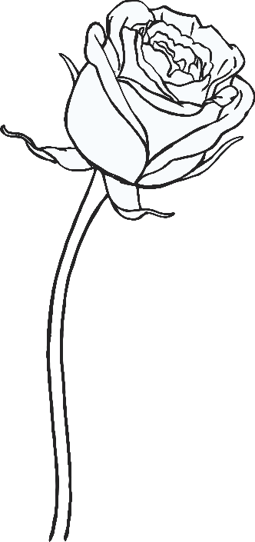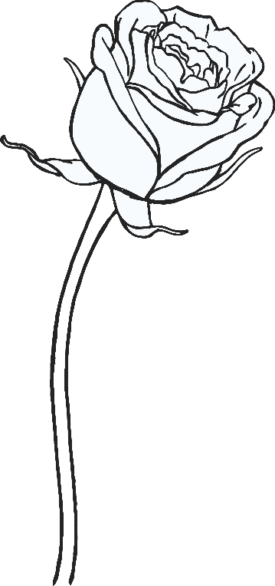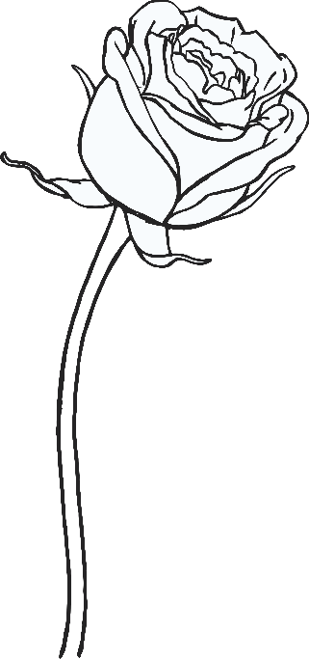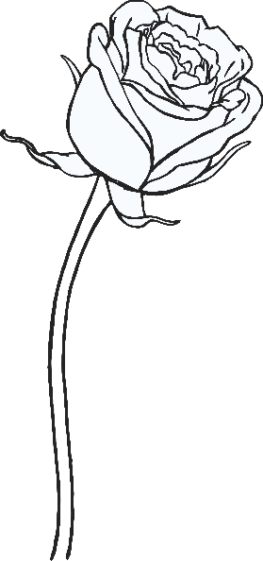

© 2019 Little Owls Resources

I

you!

love

© 2019 Little Owls Resources

LOVE

© 2019 Little Owls Resources

Happy

VALENTINE’S

DAY

© 2019 Little Owls Resources



Happy

Valentine’s Day!

I love you!

© 2019 Little Owls Resources

LOVE

© 2019 Little Owls Resources

© 2019 Little Owls Resources

Be my Valentine!

Happy

Valentine’s Day!