© 2019 Little Owls Resources

Happy

Valentine’s Day!

© 2019 Little Owls Resources

I love you!

© 2019 Little Owls Resources

Be my Valentine!

© 2019 Little Owls Resources

Happy

Valentine’s Day!

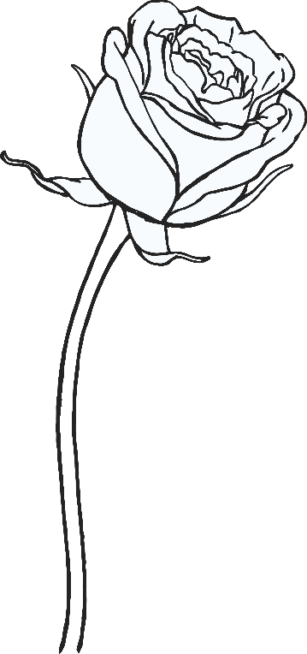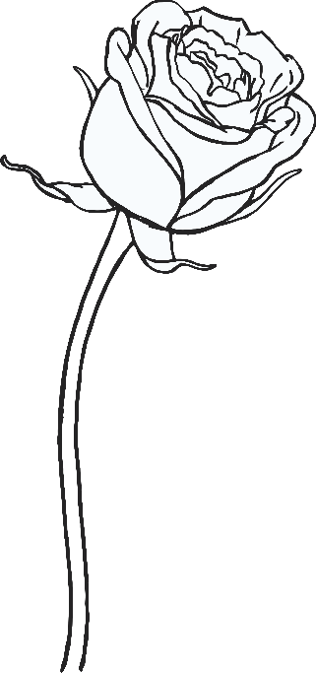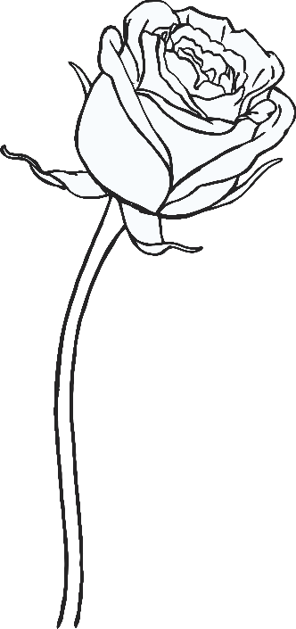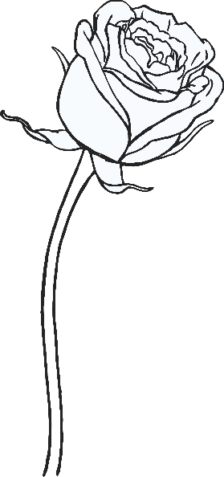

Happy

Valentine’s Day!

© 2019 Little Owls Resources

I love you!

© 2019 Little Owls Resources

Happy

VALENTINE’S

DAY

© 2019 Little Owls Resources

© 2019 Little Owls Resources

LOVE

© 2019 Little Owls Resources

Happy Valentine’s Day

© 2019 Little Owls Resources