Valentine card templates

These card templates have detailed outlines to be used as a starting point for an art activity.

The outlines can be coloured, painted, or collaged to create an individual card design to be given to a loved one.

me very happy!

You make

me very happy!

You make

©2022 Little Owls Resources

Love

©2022 Little Owls Resources

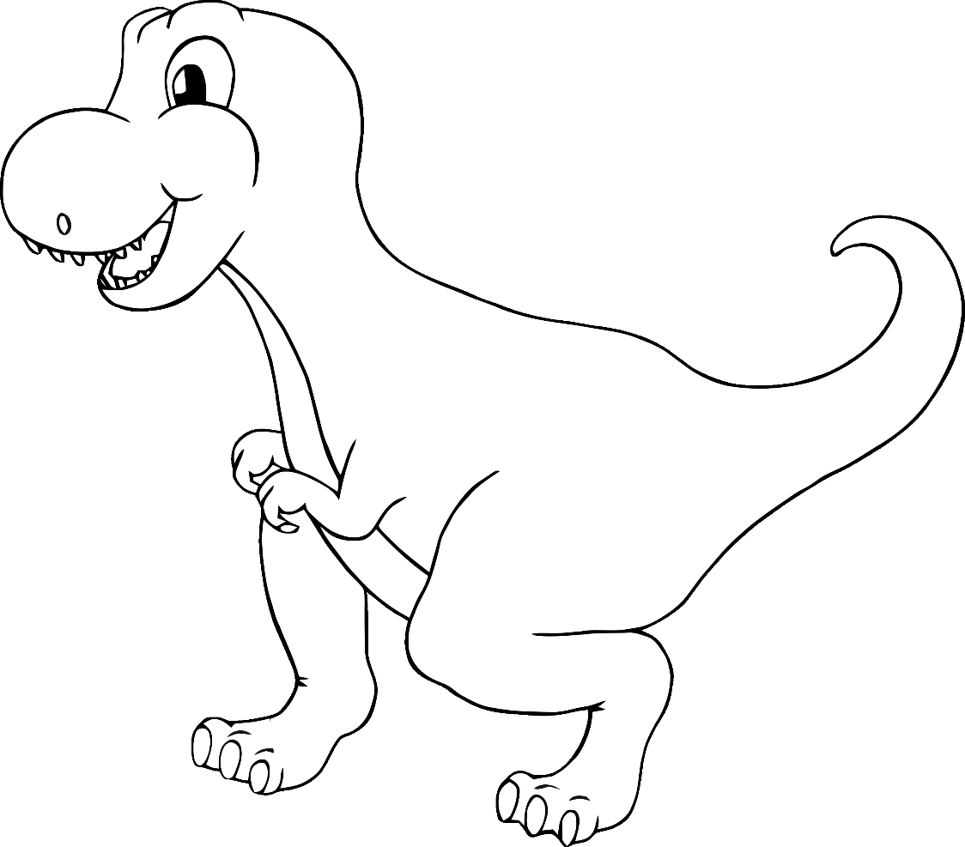

**You are so**

**!**

**roarsome**

©2022 Little Owls Resources

‘eye’ love you!

©2022 Little Owls Resources

sunshine!

You are my

©2022 Little Owls Resources

You make

me very happy!

©2022 Little Owls Resources

You’re magical!

©2022 Little Owls Resources

Valentine’s Day!

Happy

You are a STAR!

©2022 Little Owls Resources

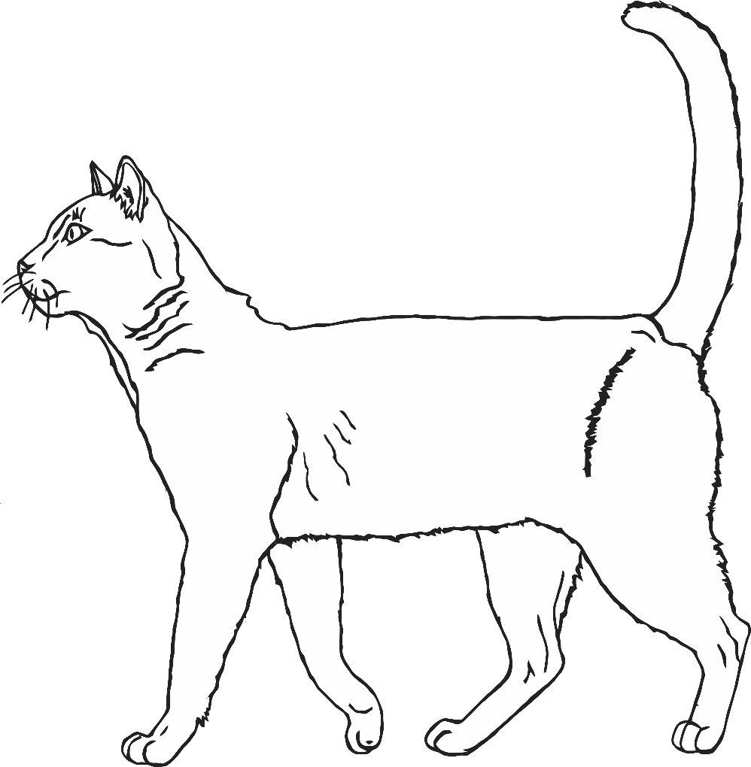

Happy Valentine’s Day!

You’re purr-fect!

©2022 Little Owls Resources

Happy Valentine’s Day!

©2022 Little Owls Resources