Valentine A4 templates

©2022 Little Owls Resources

You make

me very happy!

You make

me very happy!

for mummy and daddy

These templates have detailed outlines to be used as a starting point for an art activity.

The outlines can be coloured, painted, or collaged to create an individual poster design to be given to a loved one.

Love

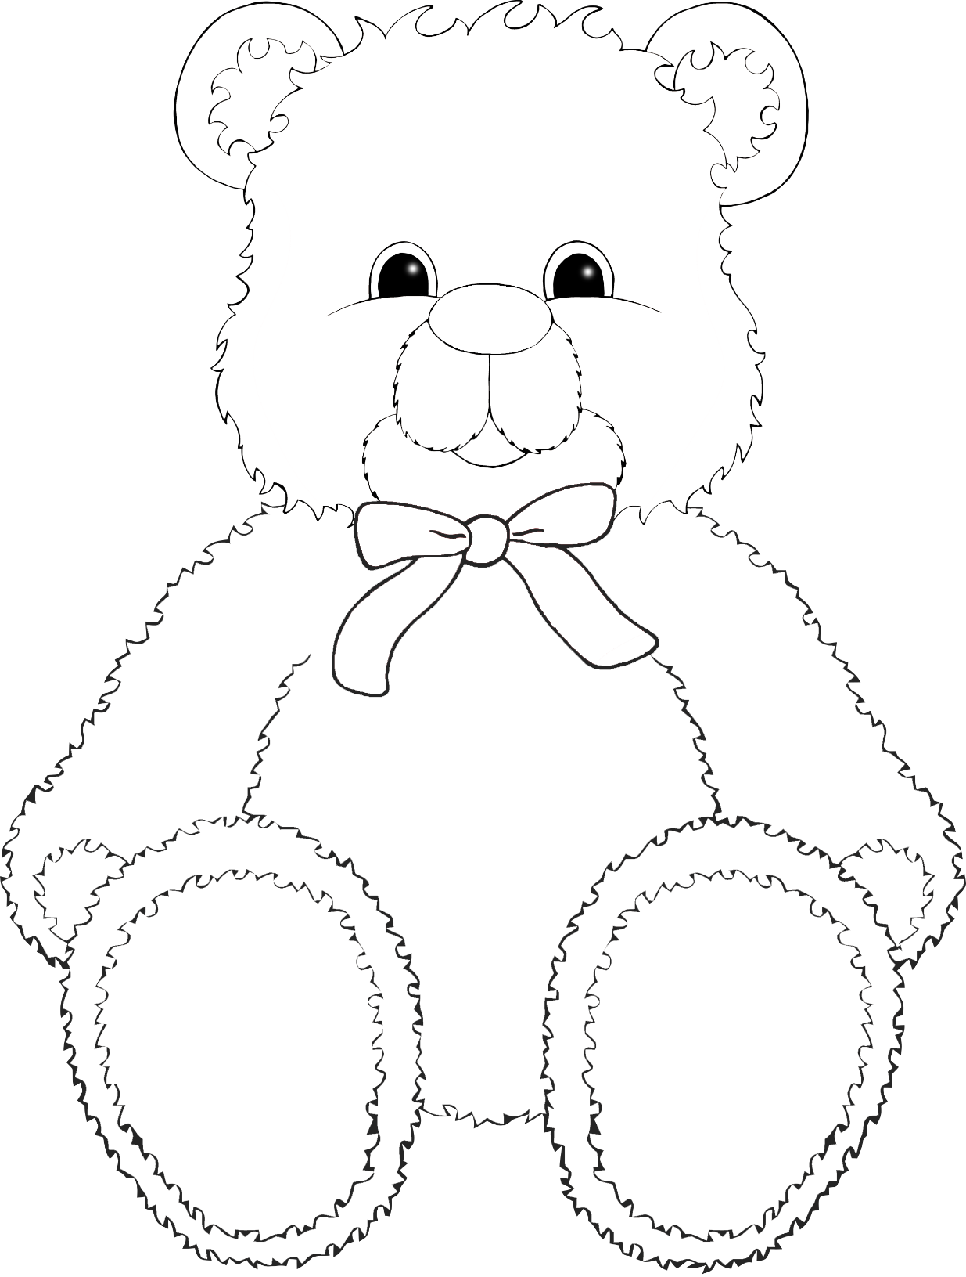

©2022 Little Owls Resources

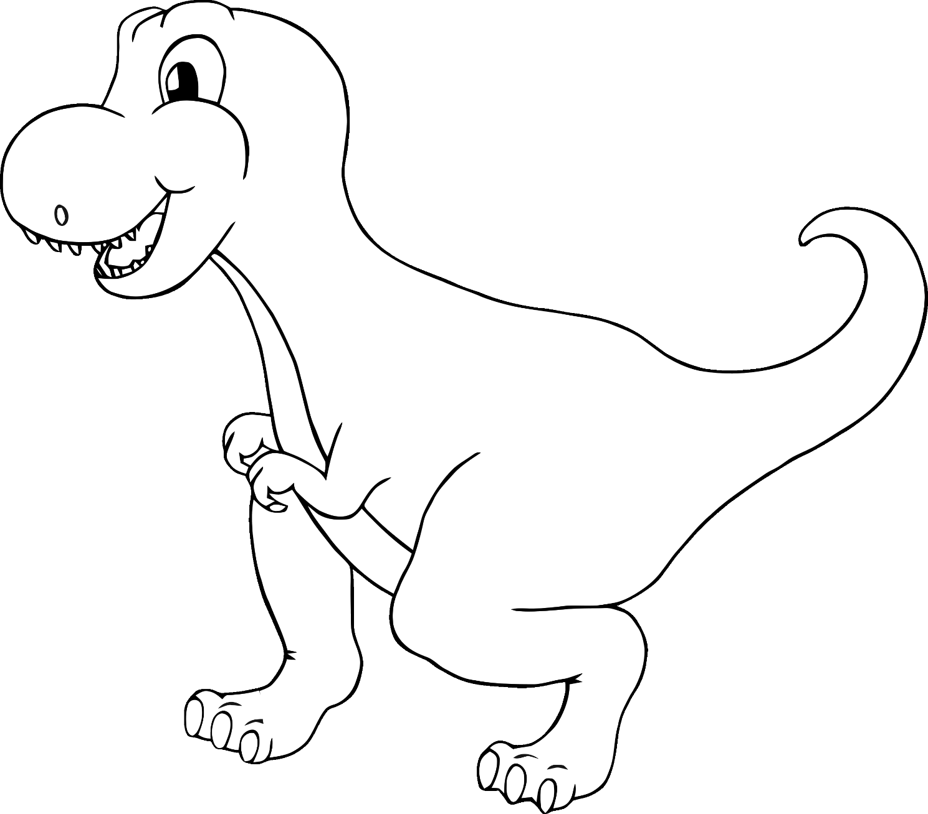

**You are so**

**!**

**roarsome**

©2022 Little Owls Resources

‘eye’ love you!



©2022 Little Owls Resources

sunshine!

You are my



©2022 Little Owls Resources

You make

me very happy!

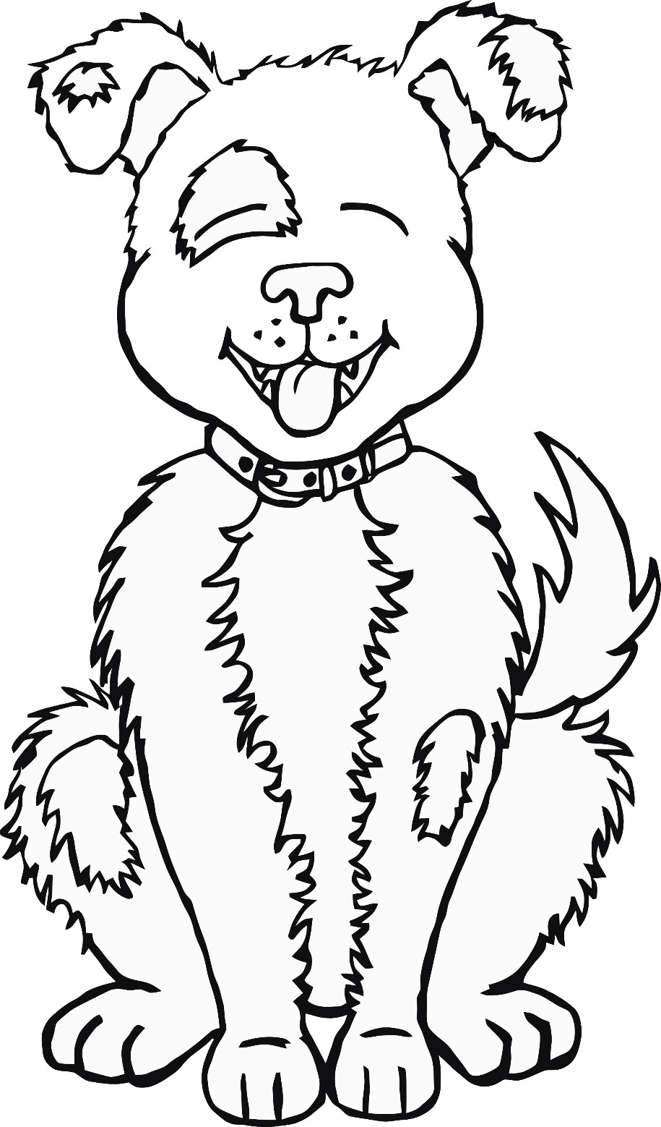

©2022 Little Owls Resources

You’re magical!

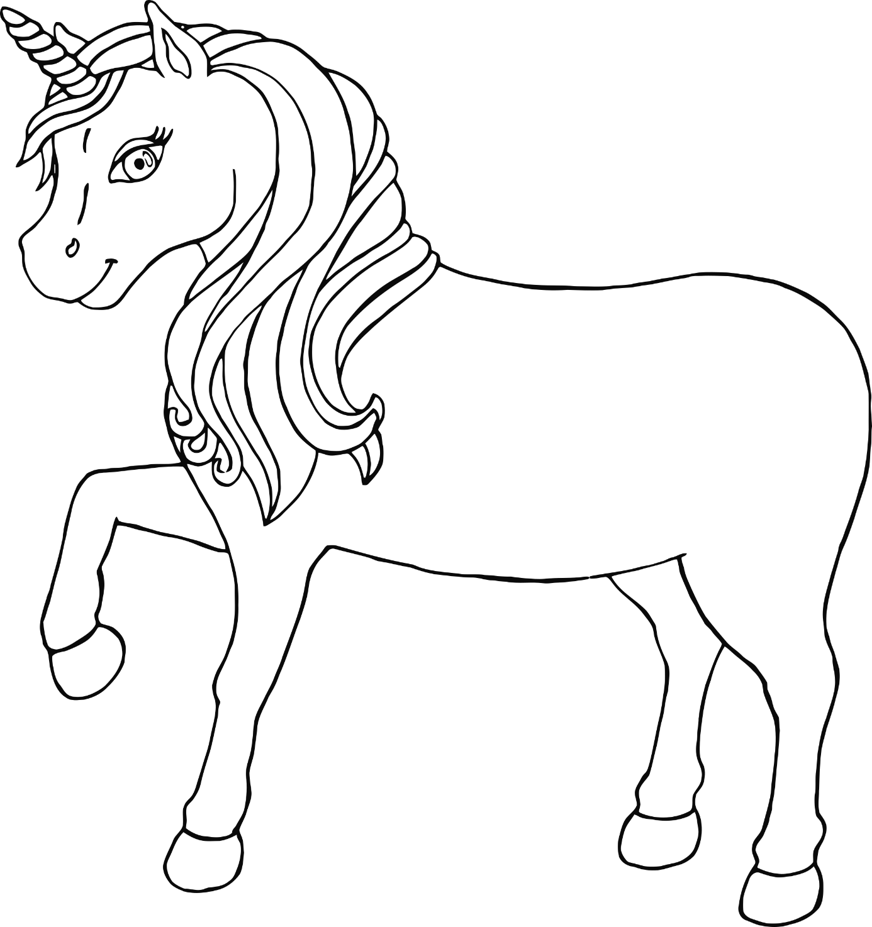

©2022 Little Owls Resources

You are a STAR!

Happy

Valentine’s Day!

©2022 Little Owls Resources

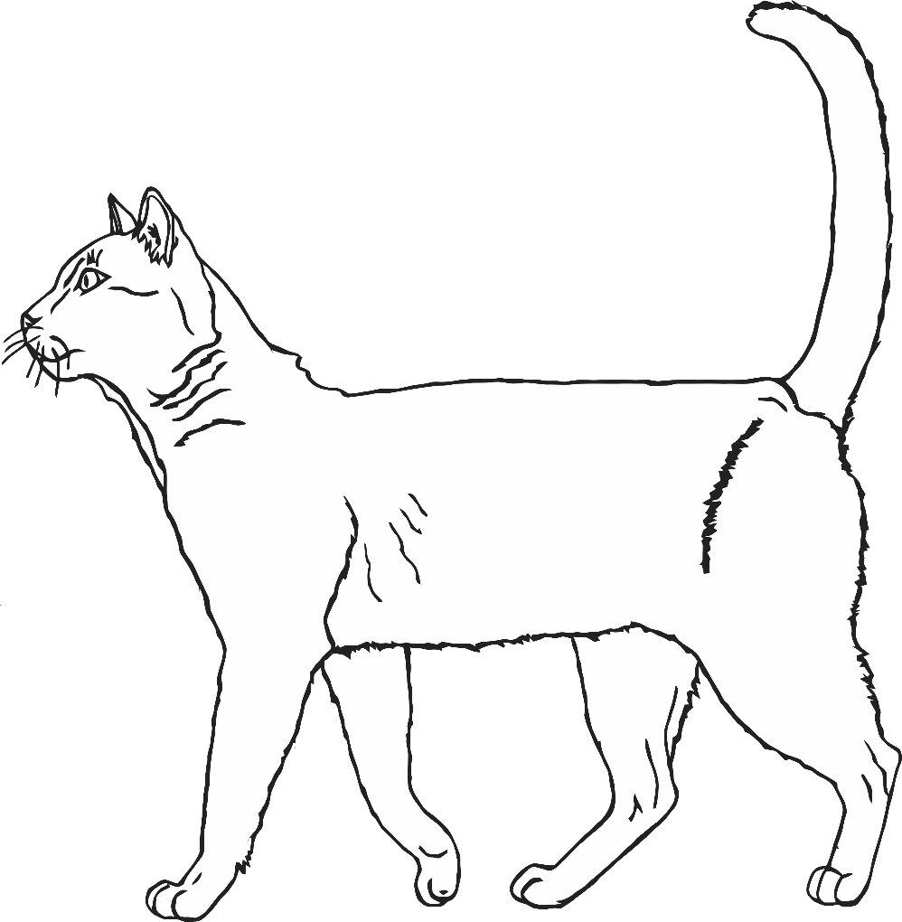

You’re purr-fect!

Happy Valentine’s Day!

©2022 Little Owls Resources

Happy Valentine’s Day!

©2022 Little Owls Resources