Name:

**v**

**booklet**

**v**

**v**

**v**

**v**

**My**

© 2020 Little Owls Resources

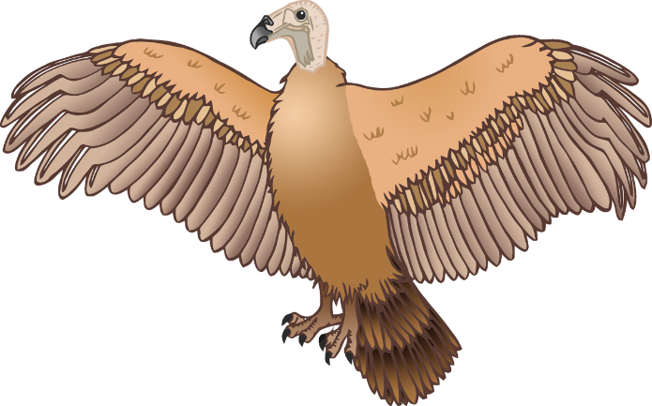

Circle the pictures that use the v sound.

Name:

**Colour** the pictures that use the v sound.

Name:

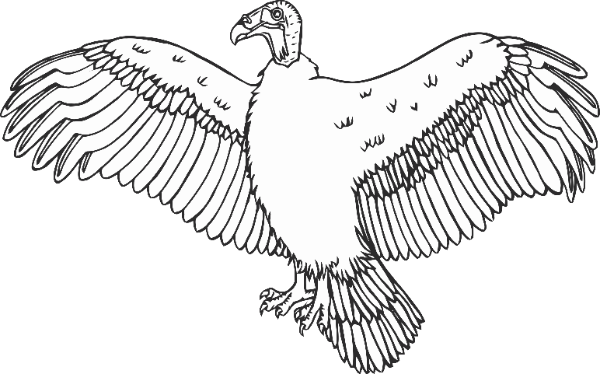

Name:

Circle the v sound.

o

v

l

p

e

v

m

v

v

i

g

Practise writing v.

Name:

**v v v**

**v v v**

v v v

v v v

v v v

___ ___ ___

Name:

a n

ket

a t

ulture

sil er

Write v and then read the word.

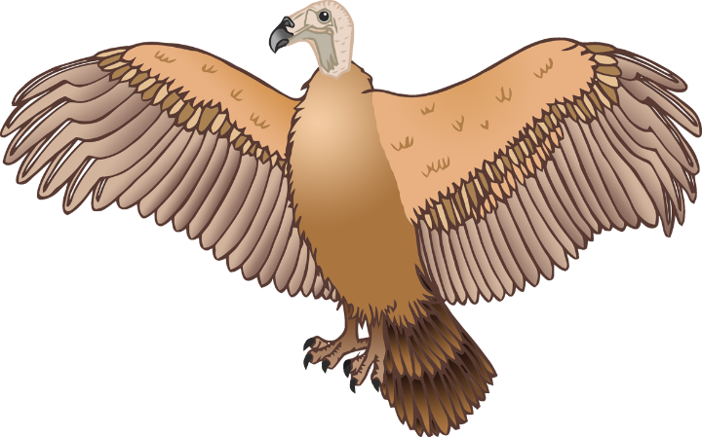

Name:

Read the words and **colour** the pictures.

van

vat

vulture

silver

Name:

Match the word with the picture.

1

silver

1

cat

1

vat

1

vulture

1

box

1

van

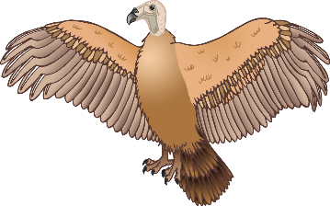

Name:

Write the words for the pictures. Tick the v words.

**✔**

Name:

Write the words for the pictures. Tick the v words.

1

1

1

1

1

1

**✔**

Name:

Read all the words. Tick the ones that are real.

**✔**

1

1

voop

1

1

van

1

1

silver

1

1

vet

1

1

vam

1

1

piv

1

1

vat

1

1

sev

1

1

**w**uv

1

1

vulture

Name:

Read the words and draw pictures for them.

1

1

vet

van

1

1

vinegar

silver