**High Frequency Words**

**Phase 3 - Set 3**

**High Frequency Words**

**Phase 3 - Set 2**

**High Frequency Words**

**Phase 3 - Set 1**

© 2020 Little Owls Resources

no**w**

see

be

be

my

this

them

them

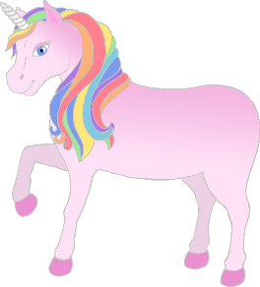

© 2020 Little Owls Resources

then

**w**ith

me

are

she

they

© 2020 Little Owls Resources

he

you

that

too

**w**ill

look

**High Frequency Words**

**Phase 3 - Set 4**

© 2020 Little Owls Resources

do**w**n

for

**w**as

her

**w**e

all

