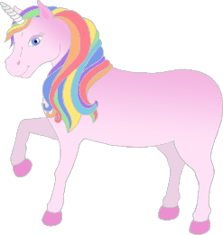

**High Frequency Words – Phase 3**

no**w**

look

too

them

**w**ith

see

for

he

she

**w**e

me

be

**w**as

you

they

all

are

my

her

**w**ill

that

this

then

do**w**n

© 2020 Little Owls Resources