© 2022 Little Owls Resources

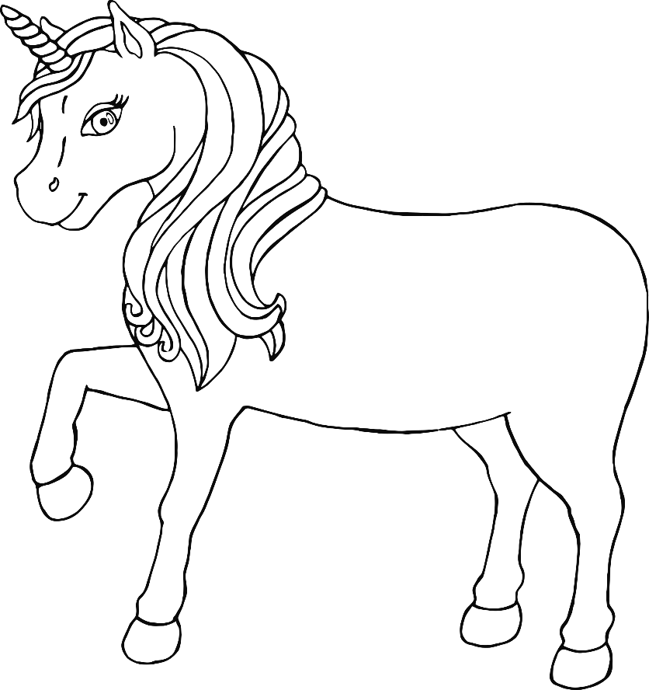

© 2022 Little Owls Resources

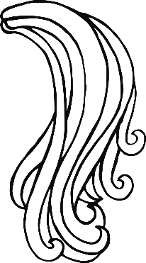

Magic!

© 2022 Little Owls Resources

© 2022 Little Owls Resources



Unicorn!

© 2022 Little Owls Resources

© 2022 Little Owls Resources



© 2022 Little Owls Resources

© 2022 Little Owls Resources