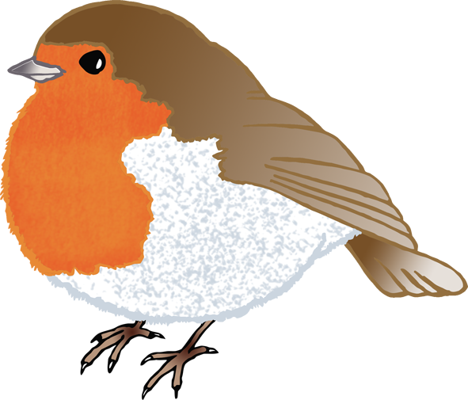

1

2

3

4

5

1

2

3

4

5

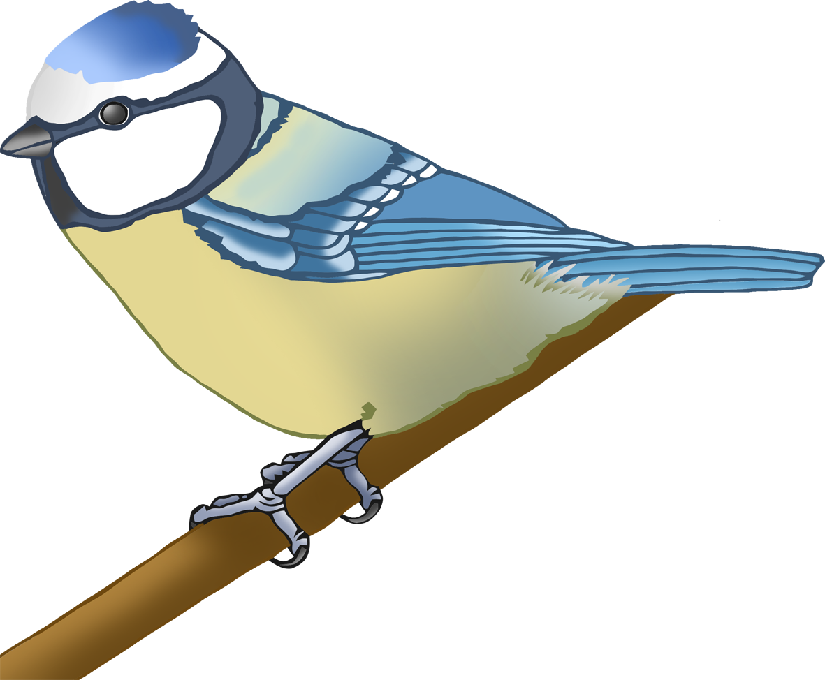

1

2

3

4

5

1

2

3

4

5

6

7

8

9

10

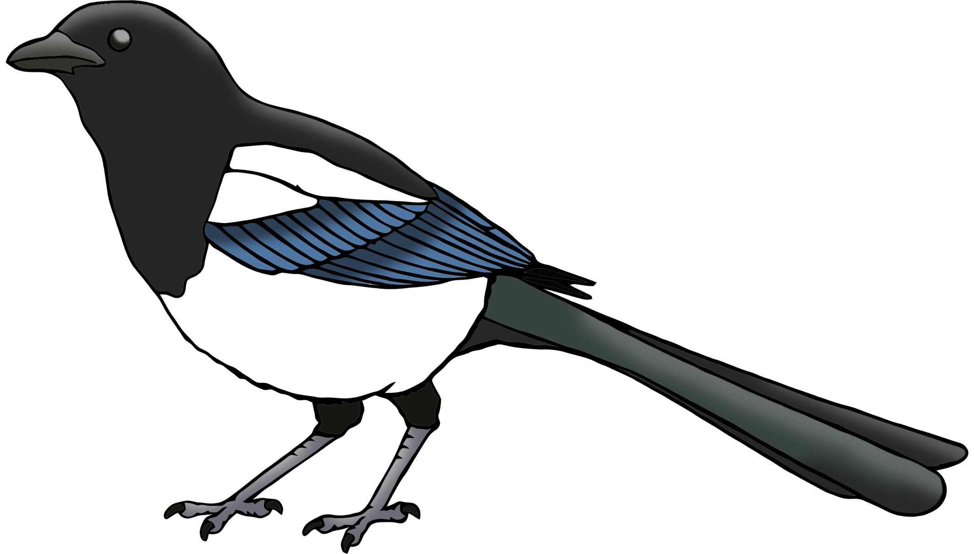

1

2

3

4

5

6

7

8

9

10