**Blackbird**

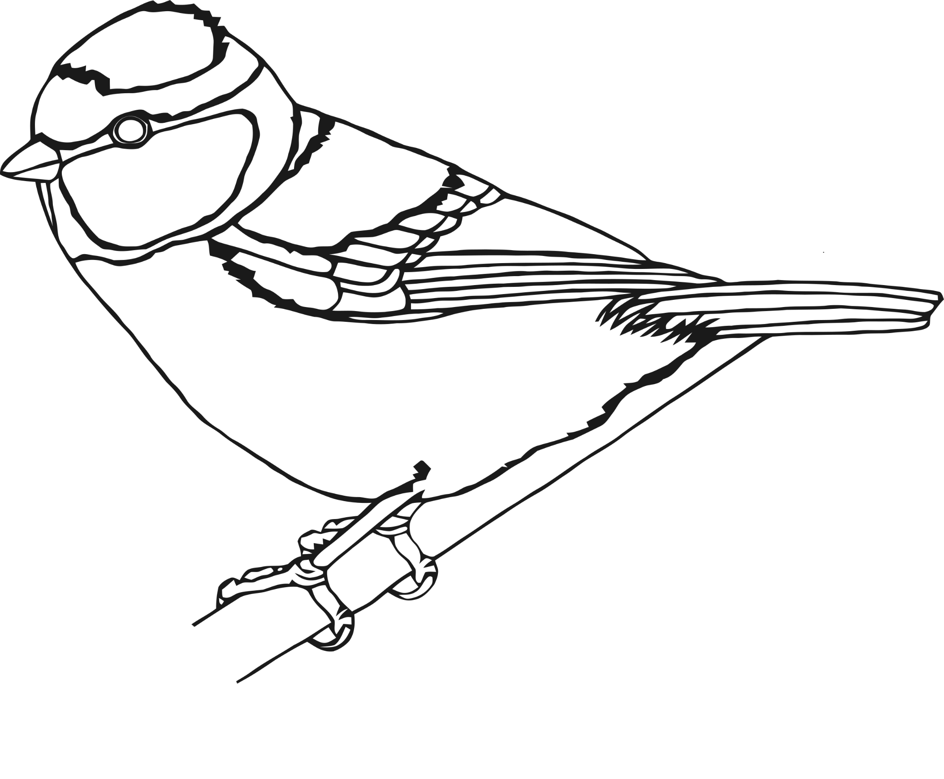

**Blue Tit**

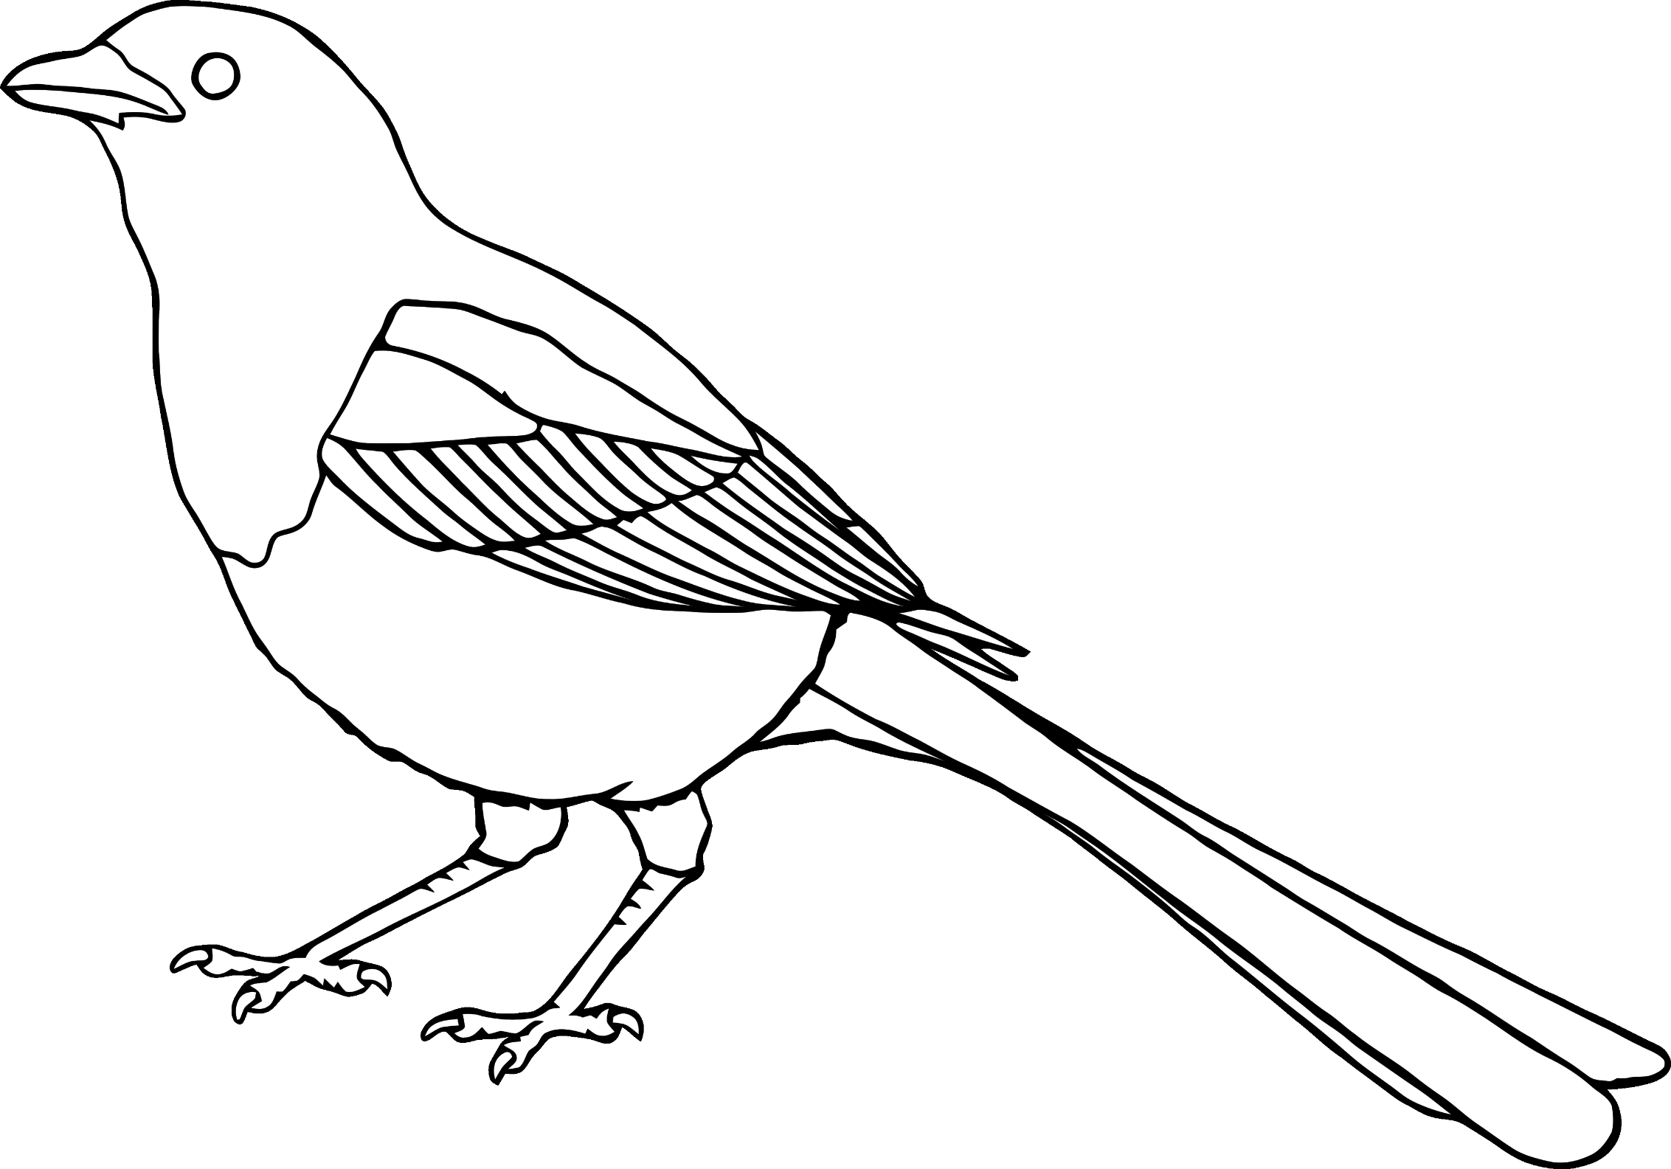

**Magpie**

**Pigeon**

**Robin**

