© 2020 Little Owls Resources

Blackbird

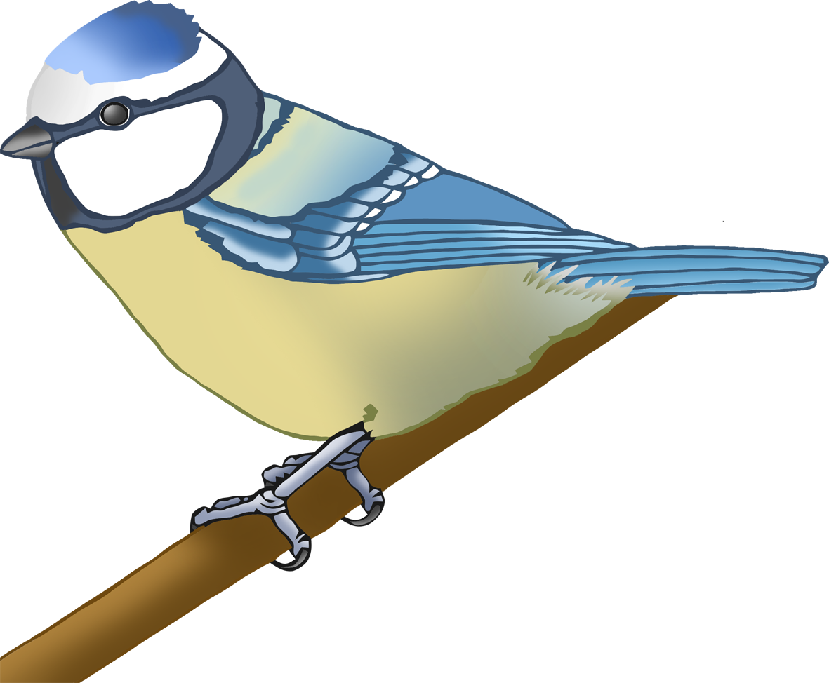

© 2020 Little Owls Resources

Blue Tit

© 2020 Little Owls Resources

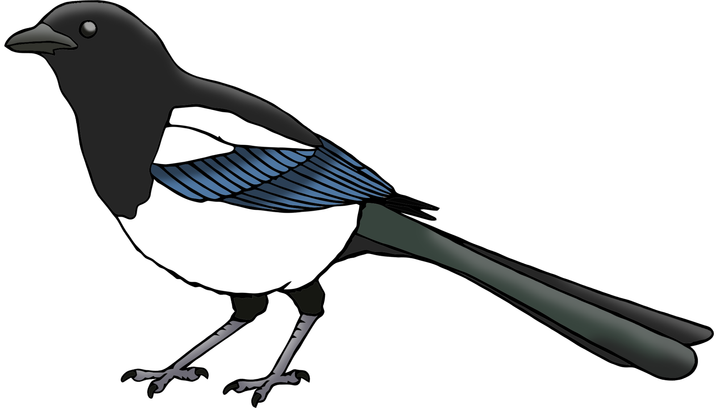

Magpie

© 2020 Little Owls Resources

Pigeon

© 2020 Little Owls Resources

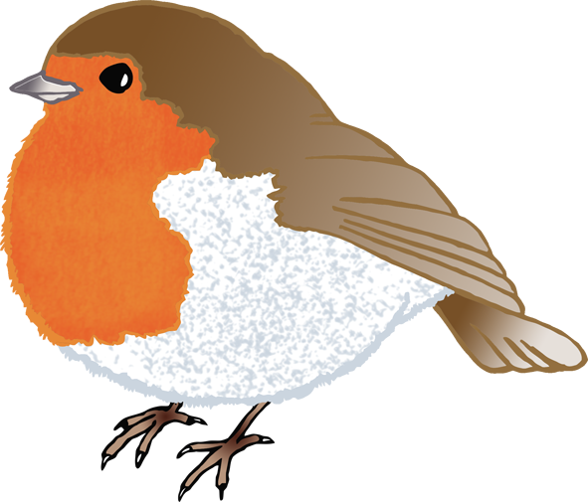

Robin