

Twinkle, twinkle, little star,

www.littleowls-premium.com © 2019 Little Owls Resources

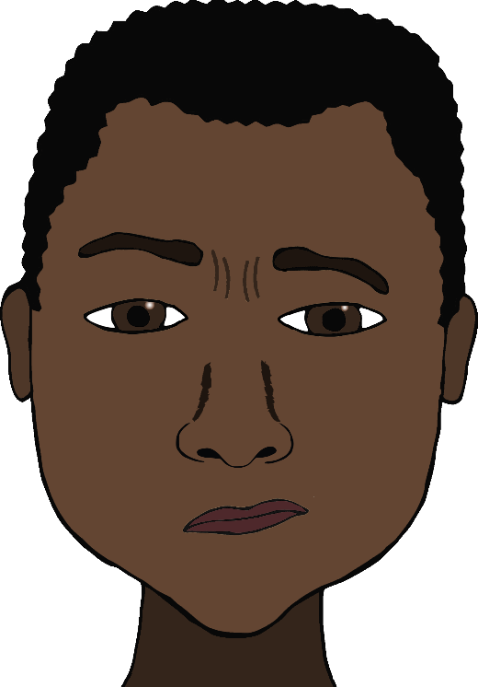

?

?

?

How I wonder what you are.

www.littleowls-premium.com © 2019 Little Owls Resources



Up above the world so high,

Like a diamond in the sky.

www.littleowls-premium.com © 2019 Little Owls Resources



**?**

Twinkle, twinkle, little star,

How I wonder what you are.

www.littleowls-premium.com © 2019 Little Owls Resources