?

?

© 2019 Little Owls Resources

© 2019 Little Owls Resources



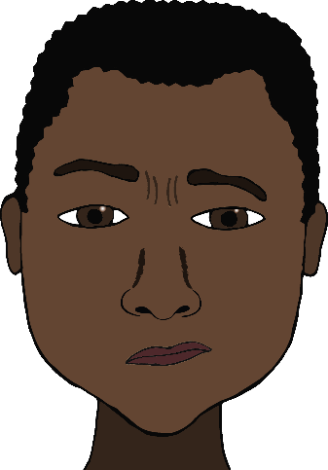

**?**

© 2019 Little Owls Resources

© 2019 Little Owls Resources

© 2019 Little Owls Resources

© 2019 Little Owls Resources

Twinkle, twinkle, little star,

How I wonder what you are.

Up above the world so high,

Like a diamond in the sky.

Twinkle, twinkle, little star,

How I wonder what you are.

© 2019 Little Owls Resources

© 2019 Little Owls Resources