**Turtle body parts**

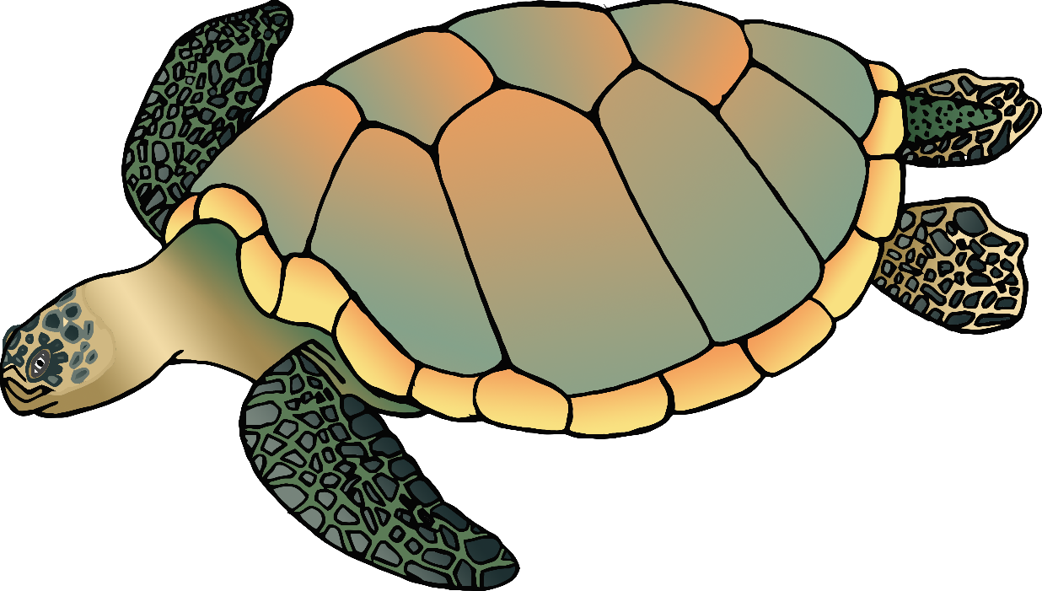

© 2020 Little Owls Resources

b

f

t

s

n

**Turtle body parts**



© 2020 Little Owls Resources

neck

shell

tail

flippers

beak

**Turtle body parts**



© 2020 Little Owls Resources