car

police car

ambulance

© 2022 Little Owls Resources

© 2022 Little Owls Resources

© 2022 Little Owls Resources

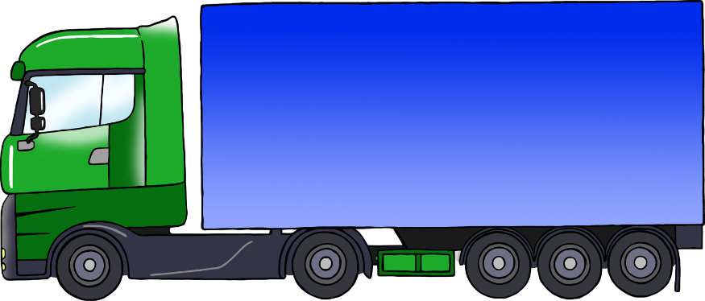

bus

lorry

motorbike

© 2022 Little Owls Resources

© 2022 Little Owls Resources

© 2022 Little Owls Resources

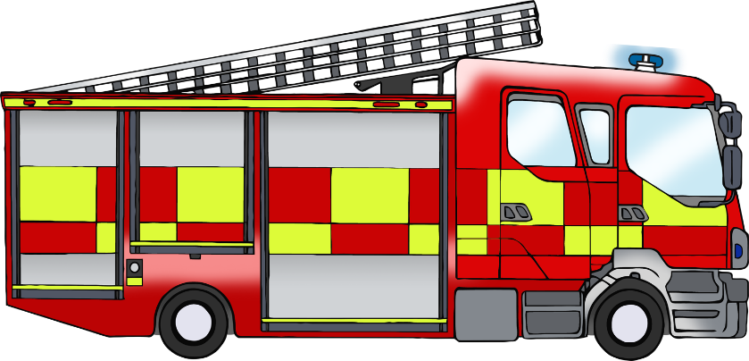

© 2022 Little Owls Resources

© 2022 Little Owls Resources

© 2022 Little Owls Resources

bicycle

tractor

fire engine

train

aeroplane

ship

© 2022 Little Owls Resources

© 2022 Little Owls Resources

© 2022 Little Owls Resources