**Transport Word Mat**

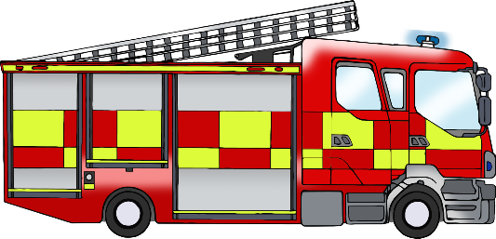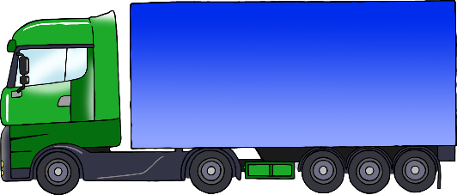

tractor

ship

fire engine

lorry

motorbike

train

bus

aeroplane

car

ambulance

police car

bicycle

© 2022 Little Owls Resources