© 2022 Little Owls Resources

© 2022 Little Owls Resources

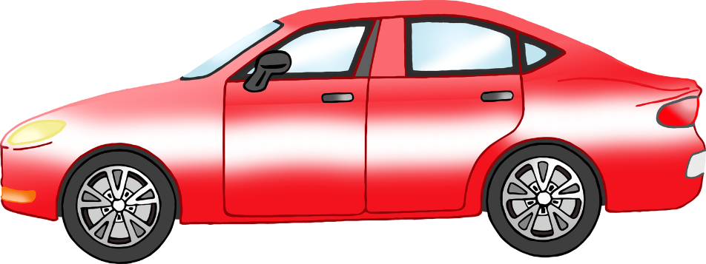

© 2022 Little Owls Resources

© 2022 Little Owls Resources

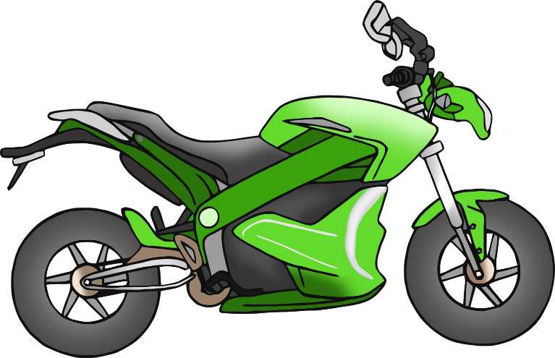

© 2022 Little Owls Resources

© 2022 Little Owls Resources

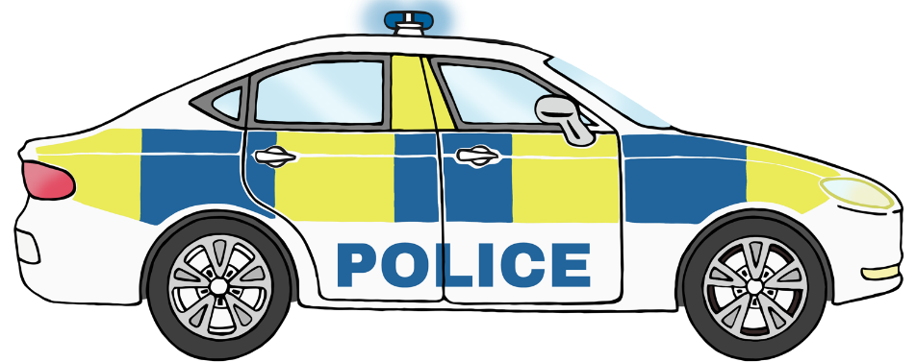

© 2022 Little Owls Resources

© 2022 Little Owls Resources

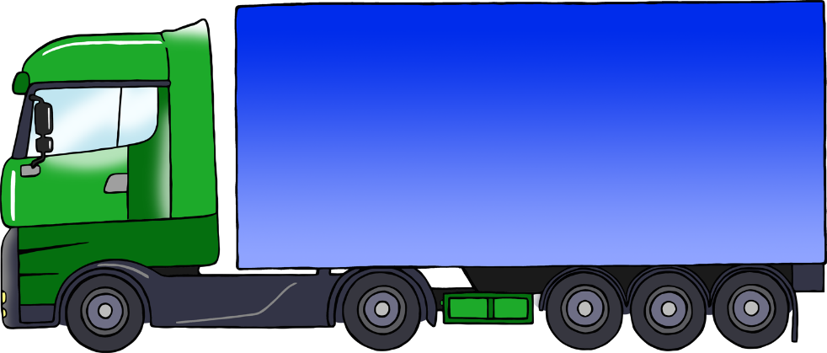

© 2022 Little Owls Resources

© 2022 Little Owls Resources

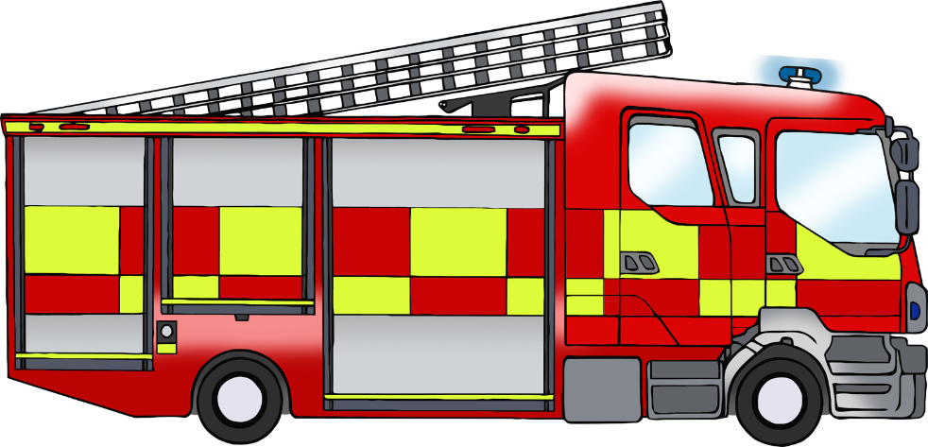

© 2022 Little Owls Resources

© 2022 Little Owls Resources

Resources

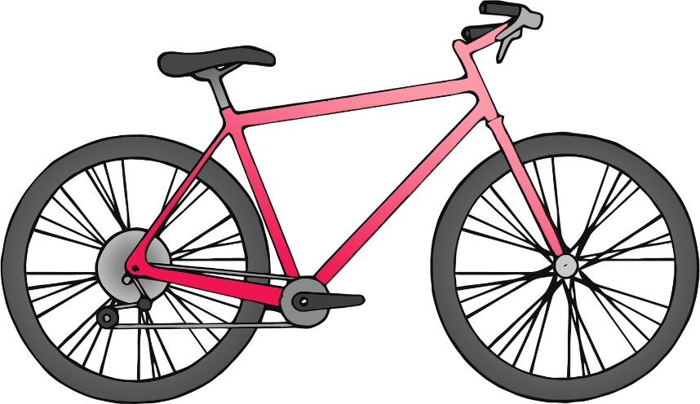

© 2022 Little Owls Resources

© 2022 Little Owls Resources

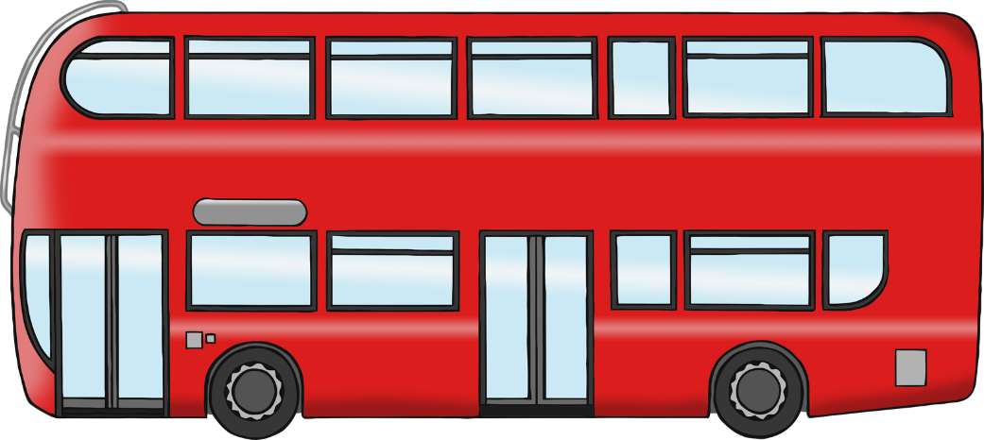

© 2022 Little Owls Resources

Owls Resources

© 2022 Little Owls Resources

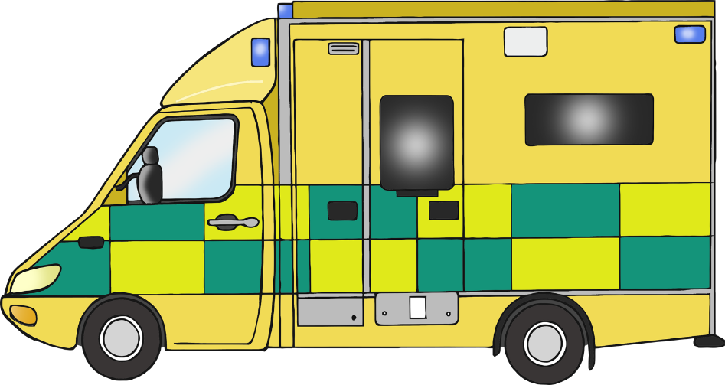

© 2022 Little Owls Resources

© 2022 Little Owls Resources

© 2022 Little Owls Resources

© 2022 Little Owls Resources

© 2022 Little Owls Resources

© 2022 Little Owls Resources

© 2020 Little Owls Resources

© 2022 Little Owls Resources

© 2022 Little Owls Resources

