© 2022 Little Owls Resources



**1**

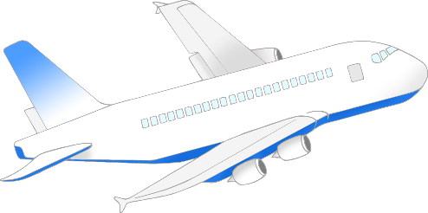

one

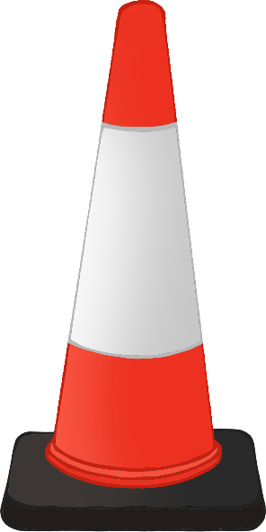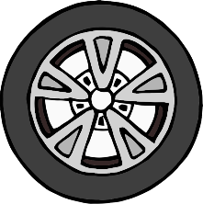

© 2022 Little Owls Resources

**2**

two

© 2022 Little Owls Resources

**3**

three

© 2022 Little Owls Resources



**4**

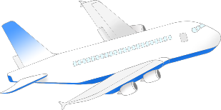

four

© 2022 Little Owls Resources



**5**



five

© 2022 Little Owls Resources



**6**

six

