Transport Descriptions

Children to look at the individual images laid out in front of them. Teacher to read a description without showing the children the card. Children to guess which mode of transport is being described to them!

Fold along the line

© 2022 Little Owls Resources

**?**

© 2022 Little Owls Resources

This vehicle carries many people.

You must buy a ticket when you get on.

You get on and off at stops.

**?**

© 2022 Little Owls Resources

This vehicle carries many people.

You get on and off at stations.

This vehicle moves on tracks.

**?**

© 2022 Little Owls Resources

This vehicle has large wheels.

This vehicle pulls along heavy loads.

This vehicle is used on a farm.

**?**

© 2022 Little Owls Resources

This vehicle has flashing lights.

This vehicle is used in emergencies.

This vehicle drives to a hospital.

**?**

© 2022 Little Owls Resources

This is a small vehicle.

You must move it yourself.

It only has space for one person.

**?**

© 2022 Little Owls Resources

This vehicle has flashing lights.

This vehicle is used in emergencies.

This vehicle carries firefighters.

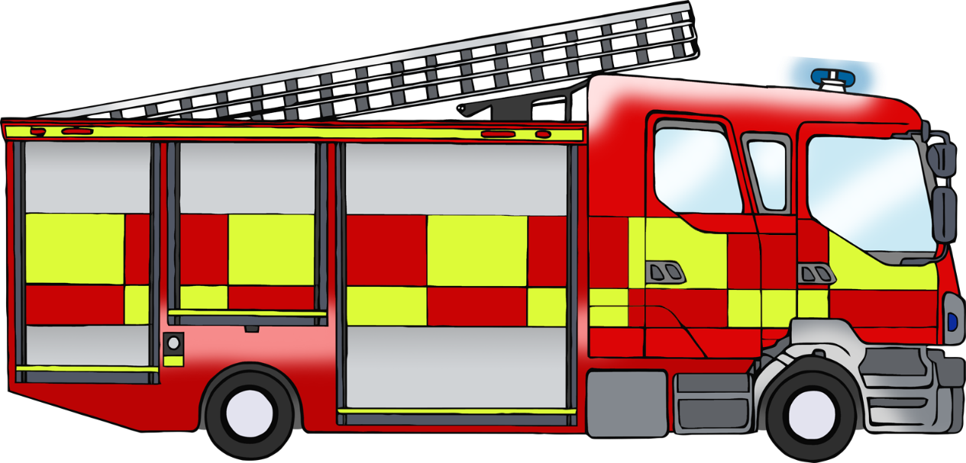

**?**

© 2022 Little Owls Resources

This vehicle moves on the road.

This is a large vehicle.

This vehicle carries lots of items in the back.

**?**

© 2022 Little Owls Resources

This is a noisy vehicle.

It only has space for one person.

You must wear a helmet to drive this.

**?**

© 2022 Little Owls Resources

This vehicle has flashing lights.

This vehicle is used in emergencies.

This vehicle carries police officers.

© 2022 Little Owls Resources

This is a very large vehicle.

This vehicle has many small windows.

This vehicle can fly.

**?**

© 2022 Little Owls Resources

This vehicle moves on the road.

It has room for a small group of people.

There are many of these on the roads.

**?**

© 2022 Little Owls Resources

This is a very large vehicle.

It has many windows.

This vehicle moves through the water.

**?**

© 2022 Little Owls Resources

© 2022 Little Owls Resources

© 2022 Little Owls Resources

© 2022 Little Owls Resources

© 2022 Little Owls Resources

© 2022 Little Owls Resources

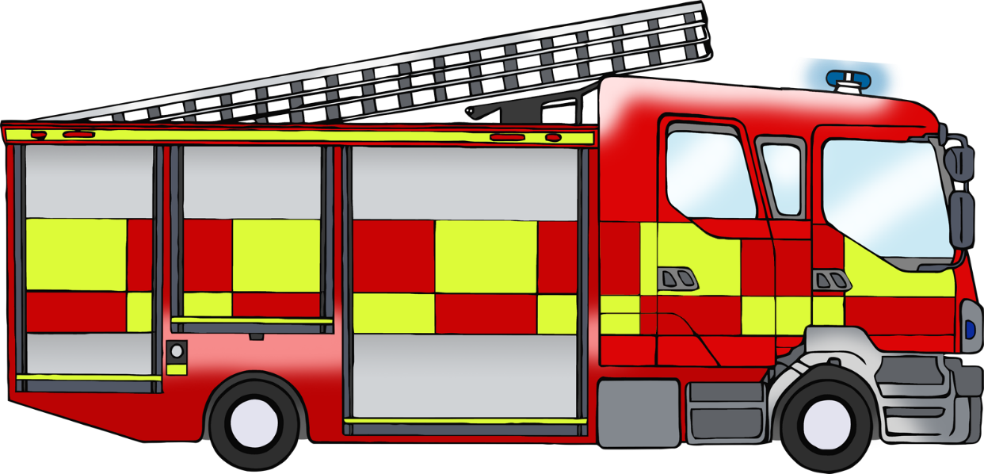

© 2022 Little Owls Resources

© 2022 Little Owls Resources

© 2022 Little Owls Resources

© 2022 Little Owls Resources

© 2022 Little Owls Resources

© 2022 Little Owls Resources