**Transport Checklist** ✔️✔️✔️

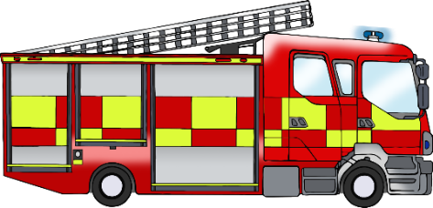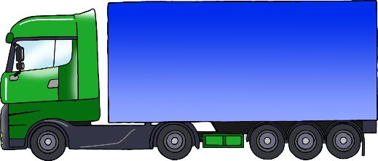

© 2022 Little Owls Resources

**Transport Checklist** ✔️✔️✔️

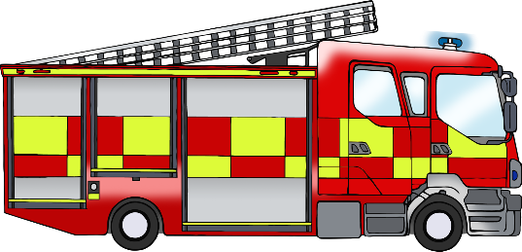

tractor

lorry

aeroplane

train

ambulance

bus

ship

motorbike

bicycle

fire engine

police car

car

© 2022 Little Owls Resources