**car**

**car**

© 2022 Little Owls Resources

**train**

© 2022 Little Owls Resources

**train**

**motorbike**

**motorbike**

© 2022 Little Owls Resources

**police car**

**police car**

© 2022 Little Owls Resources

**fire engine**

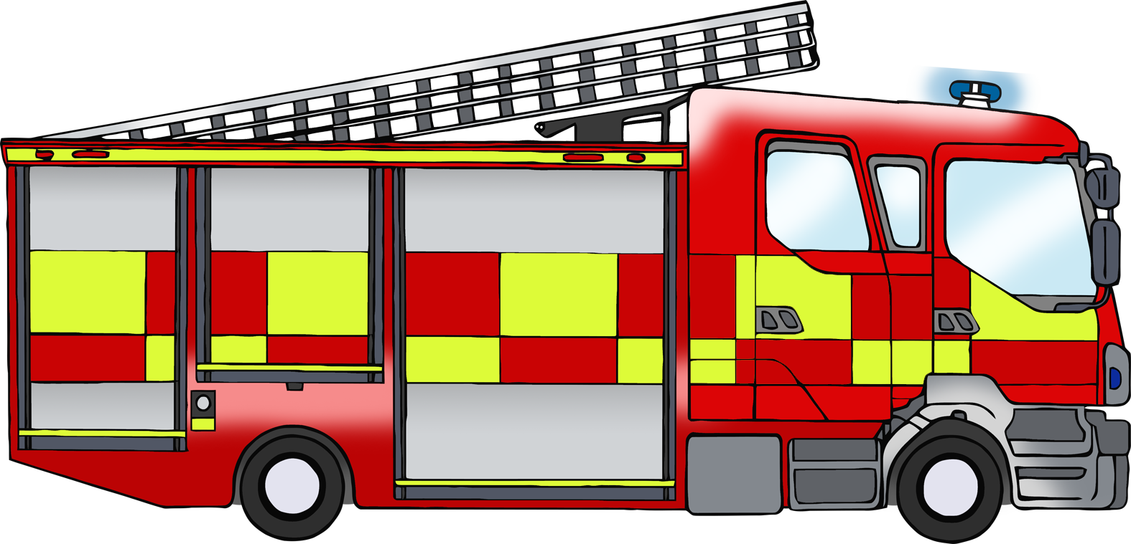

**fire engine**

© 2022 Little Owls Resources

**bicycle**

**bicycle**

© 2022 Little Owls Resources

© 2022 Little Owls Resources

**lorry**

**lorry**

**bus**

© 2022 Little Owls Resources

**bus**

**ambulance**

© 2022 Little Owls Resources

**ambulance**

**ship**

© 2022 Little Owls Resources

**ship**

© 2022 Little Owls Resources

**aeroplane**

**aeroplane**

© 2022 Little Owls Resources

**tractor**

**tractor**