Traffic Light Fans

Traffic light fans with Green, Amber and Red lights.

Designed to be cut out, laminated and then joined with a split pin or short treasury tag.

Children can use to self-evaluate how well they think they have understood/enjoyed an activity.

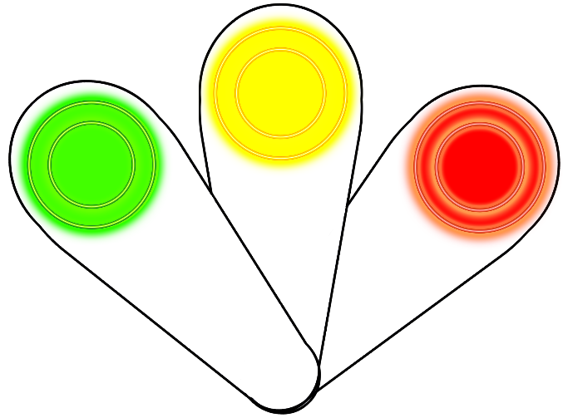





© 2019 Little Owls Resources

© 2019 Little Owls Resources

© 2019 Little Owls Resources