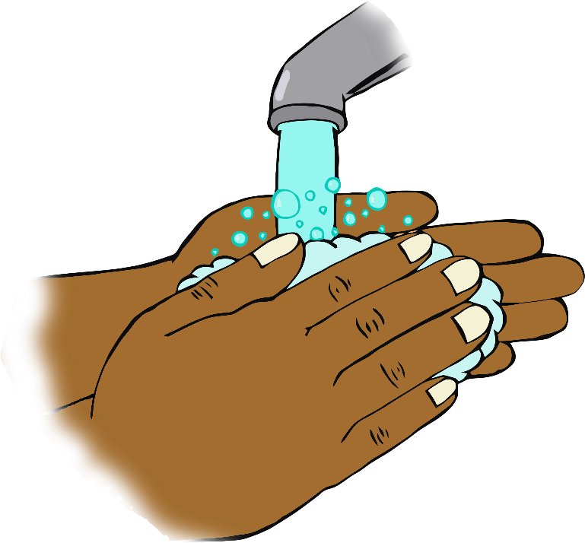

**After using the toilet…**

**Wash your hands!**