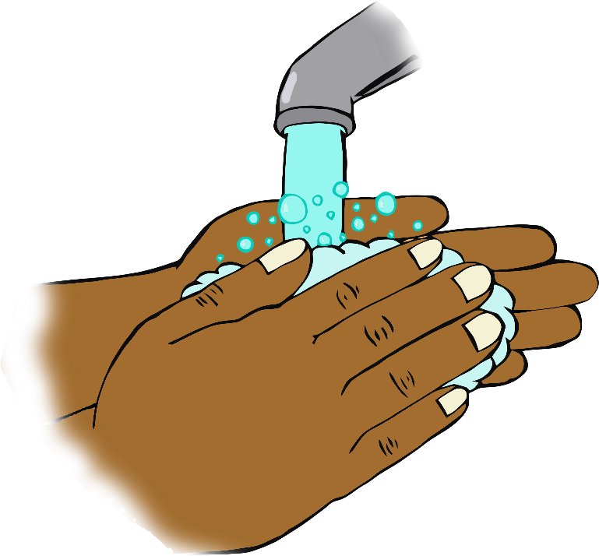

© 2020 Little Owls Resources

**After using the toilet…**

**Wash your hands!**