**Weather**

© 2022 Little Owls Resources

Today the weather is…

hail

rainy

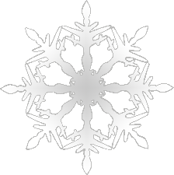

© 2022 Little Owls Resources

© 2022 Little Owls Resources

© 2022 Little Owls Resources

© 2022 Little Owls Resources

© 2022 Little Owls Resources

© 2022 Little Owls Resources

© 2022 Little Owls Resources

© 2022 Little Owls Resources

cloudy and sunny

cloudy

stormy

snowy

windy

sunny