Today

© 2020 Little Owls Resources

**Date**

**Month**

**Year**

**Weather**

**Day**

**Season**

© 2020 Little Owls Resources

Years

Dates

Months of the year

Days of the week

© 2020 Little Owls Resources

Weather

Seasons

Tuesday

Thursday

Wednesday

Friday

Monday

© 2020 Little Owls Resources

Saturday

© 2020 Little Owls Resources

March

February

January

Sunday

© 2020 Little Owls Resources

June

May

April

August

July

© 2020 Little Owls Resources

31

31st

November

October

September

December

1

2

3

© 2020 Little Owls Resources

13

14

15

7

8

9

10

11

12

4

5

6

16

17

18

19

20

21

22

23

24

25

26

27

28

29

30

© 2020 Little Owls Resources

1st

2nd

3rd

© 2020 Little Owls Resources

13th

14th

15th

12th

11th

10th

9th

8th

7th

4th

5th

6th

© 2020 Little Owls Resources

30th

29th

28th

27th

26th

25th

24th

23rd

22nd

21st

20th

19th

18th

17th

16th

© 2020 Little Owls Resources

2024

2025

2020

2021

2026

2027

2022

2023

© 2020 Little Owls Resources

© 2020 Little Owls Resources

© 2020 Little Owls Resources

© 2020 Little Owls Resources

**Winter**

**Autumn**

**Summer**

**Spring**

Rainy

Hail

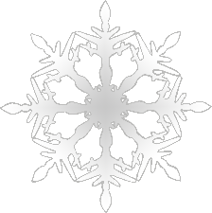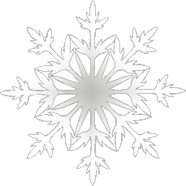

© 2020 Little Owls Resources

© 2020 Little Owls Resources

© 2020 Little Owls Resources

© 2020 Little Owls Resources

© 2020 Little Owls Resources

© 2020 Little Owls Resources

© 2020 Little Owls Resources

© 2020 Little Owls Resources

Stormy

Snowy

Windy

Sunny

Clouds and Sunshine

Cloudy