© 2021 Little Owls Resources

**Tigers – Can you add some stripes?**

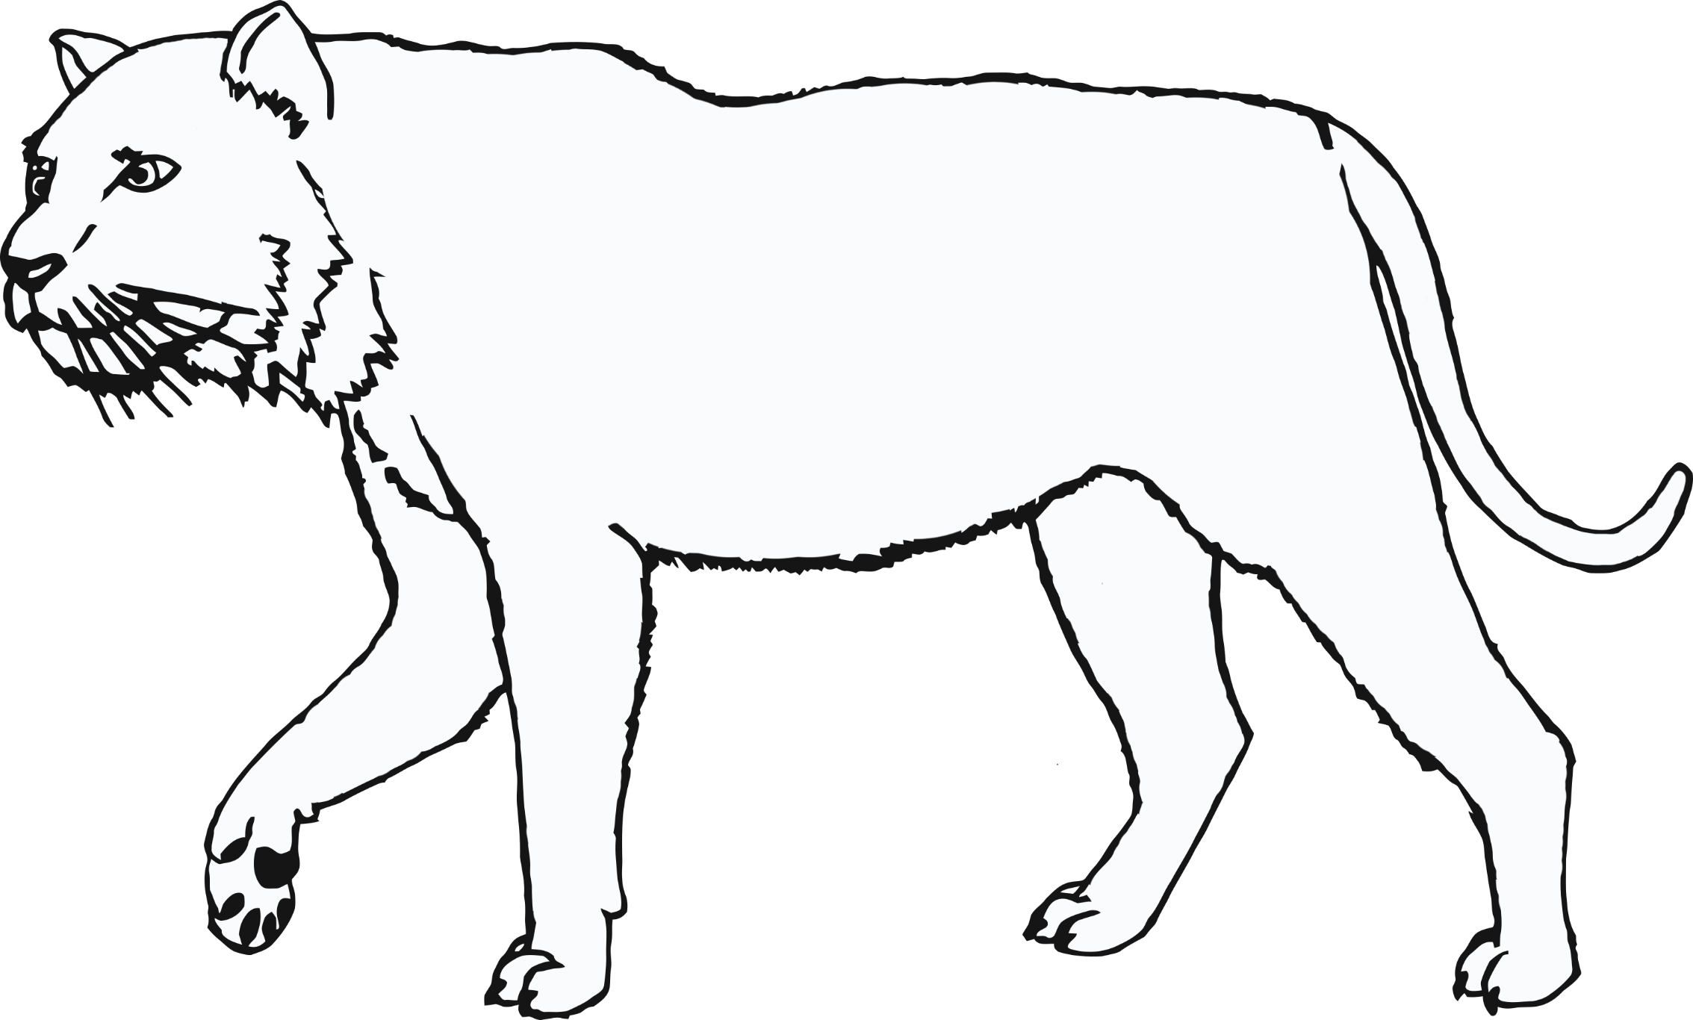

© 2021 Little Owls Resources

**Tigers – Can you add some stripes?**



